Appendices
The restructuring of the Belgian labour market, 1986-2020:
Nick Deschacht & Céline Detilleux
KU Leuven – Department of Economics

Appendix A – The EAK and EU-LFS data

Between 1999 and 2004, Eurostat only publishes data for the second quarter while Statbel publishes the annual data. The distinction in the second period can be explained by the 2017 EAK’s major reform after which the data have been collected using a rotating panel. Indeed, while respondents were only interviewed once until 2016, from 2017 on they were interviewed at 4 different times within a period of a year and an half. Respondents are interviewed for two consecutive quarters than are left out of the sample during the next two semesters and then are re-interviewed for two consecutive quarters (note that we cannot take advantage of this panel structure since the received data do not allow us to follow individual over time). The data published by Eurostat from 2017 on, on the other hand, only corresponds to respondents’ first interview. For these two reasons, the EAK has a more precise representation of the Belgian population and we have thus decided to run our main analysis for Belgium using the EAK dataset. The EU-LFS data were used when studying the comparisons between Belgium and its neighboring countries.
Statbel and Eurostat provide weighting coefficients so that we can extrapolate our sample to the Belgian (or its neighboring countries) population. In order to calculate the weights, Statbel has, a posteriori, stratified the population and the sample based on provinces, sex and age (5 years categories) and has then computed the weighting coefficient within each of the groups based on the national register. These weighting coefficients also adjust for sample non-response.

Appendix B – Harmonization of the sectoral classifications

The sectors in the EAK and the EU-LFS datasets are defined based on the NACE classification which is the “statistical classification of economic activities in the European Community” (Eurostat, 2008). Over the years, the NACE classification has gone through several revisions which results in a number of breaks in the time series data about sectors in the EAK and EU-LFS (Tables B1). For example, the break between the NACE70 and the Belgian classification “NACE-BEL 1993”, which is equivalent to the European classification “NACE-Rev. 1”, corresponds to the revision drawn up in 1990 and established by Eurostat so that the code could be harmonized with the International Standard Industrial Classification (ISIC). Similarly, “NACE-BEL 2008”, which is equivalent to “NACE-Rev. 2”, describes the major revision work of the international integrated system of economic classifications which took place between 2000 and 2007. This revision was necessary to reflect the technological developments and structural changes of the economy. Finally, “NACE-BEL 2003” is equivalent to the minor revision of the “NACE-Rev. 1” (the “NACE-Rev. 1.1”) which occurred in 2002.
Table B1. Sectoral classifications in the EAK and EU-LFS, 1986-2020
Year | 86 |  |  |  | 90 |  |  |  |  | 95 |  |  |  |  | 00 |  |  |  |  | 05 |  |  |  |  | 10 |  |  |  |  | 15 |  |  |  |  | 20
EAK | NACE 70  (3 digits) |  |  |  |  |  |  | NACE-BEL 93  (3 digits) |  |  |  |  |  | NACE-BEL 2003  (2 digits) |  |  |  |  |  |  |  |  | ª |  | NACE-BEL 2008  (2 digits)
EU-LFS |  |  |  |  |  |  | NACE Rev. 1  (1 digits) |  |  |  |  |  |  |  |  |  |  |  |  |  |  |  |  | NACE Rev. 2  (1 digits)
Notes: ª In 2008 and 2009 the EAK contains both NACE-BEL 2003 (2 digits) and NACE-BEL 2008 (2 digits).

The NACE codes are defined at different levels: the most detailed sectoral information is the NACE code at the 4 digits levels (“classes”). The 4 digit classes can be aggregated to the 3 digits level (“groups”). The groups can be further aggregated to the 2 digits level (“divisions”) or to the less detailed level categorized by an alphabetic letter (“sections”). A listing of all European NACE codes is published at https://ec.europa.eu/eurostat/ramon/index.cfm?TargetUrl=DSP_PUB_WELC.
The changes in the sectoral classifications make it hard to study sectoral changes over time. We thus first needed to harmonize the different classifications to obtain consistent time series of sectoral information. There are correspondence tables which permit conversions between the different classifications, yet, conversions are only straightforward in case of 1-to-1 or many-to-1 changes from the old to the new classification: that is, when one or many groups from the old classification can be converted to a single group in the new classification. In the 1-to-many and the many-to-many cases, the conversion is more complex and requires researchers to make some choices on how to convert the codes. The following paragraph explains the various choices and assumptions that we made in order to harmonize the classifications.
In the EAK dataset, we first converted the NACE70 to the NACE-BEL 1993 (or NACE Rev. 1) 2 digits codes using Eurostat correspondence table (Eurostat, 1996). This correspondence table is given at the most detailed level, i.e. between the NACE70 5 digits and the NACE Rev. 1 4 digits codes, but we have aggregated the codes so that it applies to our time series. When there were no 1-to-1 correspondence between the two classifications, that is when one 3 digits NACE 70 code corresponded to many 2 digits NACE Rev.1 codes, we use the NACE-BEL 1993 2 digits code that most frequently appears as a correspondence of the NACE70 3 digits code. Table B2 shows the resulting correspondence table.

Table B2. Correspondence table between NACE70 and NACE-BEL 1993 (2 digits)
NACE-BEL 1993  (2 digits) | Description | NACE70
1 | Agriculture, hunting and forestry | 11-13
2 | Forestry, logging and related service activities | 21-22
5 | Fishing, operation offish hatcheries and fish farms: service activities incidental to fishing | 31-34
10 | Mining of coal and lignite; extraction of peat | 111-112
11 | Extraction of crude petroleum and natural gas; service activities incidental to oil and gas extraction, excluding surveying | 131-134
12 | Mining of uranium and thorium ores | 151
13 | Mining of metal ores | 211-212
14 | Other mining and quarrying | 231-239
15 | Manufacture of food products and beverages | 411-428
16 | Manufacture of tobacco products | 429
17 | Manufacture of textiles | 431-439  455
18 | Manufacture of wearing apparel: dressing and dyeing of fur | 453-454  456
19 | Tanning and dressing of leather; manufacture of luggage, handbags, saddlery, harness and footwear | 441-452
20 | Manufacture of wood and of products of wood and cork, except furniture; manufacture of articles of straw and plaiting materials | 461-466
21 | Manufacture of pulp, paper and paper products | 471-472
22 | Publishing, printing and reproduction of recorded media | 473-474
23 | Manufacture of coke, refined petroleum products and nuclear fuel | 120  140  152
24 | Manufacture of chemicals and chemical products | 252-260
25 | Manufacture of rubber and plastic products | 481-483
26 | Manufacture of other non-metallic mineral products | 241-248
27 | Manufacture of basic metals | 221-224  311
28 | Manufacture of fabricated metal products, except machinery and equipment | 312-319
29 | Manufacture of machinery and equipment n.e.c. | 321-328  346
30 | Manufacture of office machinery and computers | 330
31 | Manufacture of electrical machinery and apparatus n.e.c. | 341-343  347-348
32 | Manufacture of radio, television and communication equipment and apparatus | 344-345
33 | Manufacture of medical, precision and optical instruments, watches and clocks | 371-374
34 | Manufacture of motor vehicles, trailers and semi-trailers | 351-353
35 | Manufacture of other transport equipment | 361-365
36 | Manufacture of furniture; manufacturing n.e.c. | 467  491-492  494-495
37 | Recycling | 621-622
40 | Electricity, gas, steam and hot water supply | 161-163
41 | Collection, purification and distribution of water | 170
45 | Construction | 500-504
50 | Sale, maintenance and repair of motor vehicles and motorcycles; retail sale of automotive fuel | 651-652
51 | Wholesale trade and commission trade, except of motor vehicles and motorcycles | 611-619  631-639
52 | Retail trade, except of motor vehicles and motorcycles: repair of personal and household goods | 641-649  653-656  671-675
55 | Hotels and restaurants | 661-667
60 | Land transport; transport via pipelines | 710-725
61 | Water transport | 730-742
62 | Air transport | 750
63 | Supporting and auxiliary transport activities; activities of travel agencies | 761-773
64 | Post and telecommunications | 790
65 | Financial intermediation, except insurance and pension funding | 811-813
66 | Insurance and pension funding, except compulsory social security | 821-823
67 | Activities auxiliary to financial intermediation | 831-832
70 | Real estate activities | 833-834  850
71 | Renting of machinery and equipment without operator and of personal and household goods | 841-847
72 | Computer and related activities | 839
73 | Research and development | 940
74 | Other business activities | 835-838  923  983
75 | Public administration and defence; compulsory social security | 911-919
80 | Education | 931-936
85 | Health and social work | 951-962
90 | Sewage and refuse disposal, sanitation and similar activities | 921
91 | Activities of membership organizations n.e.c. | 963-968
92 | Recreational, cultural and sporting activities | 493  922  971-979
93 | Other service activities | 981-982  984
95 | Private households with employed persons | 990-998
99 | Extra-territorial organizations and bodies | 0

After this first step, we obtained a harmonized time series between 1986 and 1998 in terms of the NACE-BEL 1993 two digits level. These codes were then easily converted to the NACE-BEL 2003 2 digits since these classifications do not differ at the 2 digit level.
There is no 1-to-1 correspondence between the NACE-BEL 2003 and NACE-BEL 2008 classifications at the two digits level. Even at the most detailed levels, about 45% of the NACE-BEL 2003 codes correspond to many NACE-BEL 2008 groups. Following the Eurostat method (Eurostat, 2008) we aggregated both NACE-BEL 2003 and NACE-BEL 2008 to their largest common denominator. Table B3 presents the rough 1-to-1 correspondence table between the sections. The first two columns of the table contain the new (aggregated) classification which is very similar to the NACE-BEL 2003 (1 digit) classification and the next two columns contain the corresponding NACE-BEL 2003 and 2008 (2 digits) groups. For the EU-FLS, only the NACE codes at the 1 digit are given. We thus follow the same procedure and aggregate the two classifications according to the last two columns of Table B3. This is a rough correspondence because some of the changes at the more detailed level (at the 4 digits levels) involve groups (3 digits) that shifted between divisions (2 digits) and occasionally between sections (1 digit). For example, NACE-BEL 2008 codes “01.620”, 78.100”, “79.909”, “93.299” correspond all partly to the NACE-BEL 2003 code “92.724” so that section 14 is not identical in the NACE-BEL 2003 and 2008 classifications.

Table B3. Correspondence table between NACE-BEL 2003 and NACE-BEL 2008
Common denominator | Description | NACE-BEL 2003  (2 digits) | NACE-BEL 2008  (2 digits) | NACE-BEL 2003  (1 digit) | NACE-BEL 2008  (1 digit)
1 | Agriculture, hunting, forestry and fishing | 1-2  5 | 1-3 | A  B | A
2 | Mining and quarrying | 10-14 | 5-9 | C | B
3 | Manufacturing industries | 15-37 | 10-33 | D | C
4 | Electricity, gas and water supply | 40-41 | 35  36-39 | E | D  E
5 | Construction | 45 | 41-43 | F | F
6 | Wholesale and retail trade; repair of motor vehicles and motorcycles and household goods | 50-52 | 45-47 | G | G
7 | Hotels and restaurants | 55 | 55-56 | H | I
8 | Transport, storage and communication | 60-64 | 49-53  58-63 | I | H  J
9 | Financial intermediation | 65-67 | 64-66 | J | K
10 | Real estate, renting and business activities | 70-74 | 68  69-75  77-82 | K | L  M  N
11 | Public administration | 75 | 84 | L | O
12 | Education | 80 | 85 | M | P
13 | Health and social work | 85 | 86-88 | N | Q
14 | Community, social and personal services | 90-93 | 90-93  94-96 | O | R  S
15 | Domestic services | 95-97 | 97-98 | P | T
16 | Extra-territorial organizations and bodies | 99 | 99 | Q | U

Appendix C. – Harmonization of the occupational classifications (NIS/INS and ISCO codes)

The occupations in the EAK and the EU-LFS datasets are defined based on the NIS (or INS) classification of the Belgian statistical office Statbel and on the ISCO (International Standard Classification of Occupations). Occupations are classified in the ISCO based on skill levels and skill specialization. Occupations are first divided in major groups (1 digit level) based on jobs skill levels which describe “the complexity and range of tasks and duties to be performed” and next, within each major group, they are further classified into sub-major (2 digits), minor (3 digits) and unit (4 digits) groups based on the skill specialization which is based on the field of knowledge required, on the tools and machinery used, on the materials worked on or used and on the goods and services produced.
The occupational classifications in the EAK and the EU-LFS have encountered several breaks over time which complicates the construction of homogeneous times series. Table C1 gives an overview of the different occupational classifications in the EAK and the EU-LFS since 1986 and 1993 respectively. The major break in the occupational classifications occurs in 2011 and corresponds to the introduction of the ISCO08 classification in the Labor Force Survey in a large majority of European countries. The revision of ISCO88 was necessary because over the 20 years that elapsed between the two classifications, there had been major economic developments and occupations needed to be re-defined to address the changes resulting from the impact of developments in information and communications technologies on the workforce (ILO, 2012). A listing of all ISCO88 and ISCO08 occupational groups can be found on the ILO website: https://www.ilo.org/public/english/bureau/stat/isco/intro.htm.
Table C1. Occupational classifications in the EAK and EU-LFS, 1986-2020
Year | 86 |  |  |  | 90 |  |  |  |  | 95 |  |  |  |  | 00 |  |  |  |  | 05 |  |  |  |  | 10 |  |  |  |  | 15 |  |  |  |  | 20
EAK | INS81 (3 digits) |  |  |  |  |  |  | INS91 (3 digits)  (pseudo-coded to ISCO88 3 digits) |  |  |  |  |  |  |  |  |  |  |  |  |  |  |  |  | ª | ISCO08 (4 digits)^{b}
EU-LFS |  |  |  |  |  |  |  | ISCO88 (3 digits) |  |  |  |  |  |  |  |  |  |  |  |  |  |  |  |  | ISCO08 (3 digits)
Notes: ª For 2010 the EAK contains both the surveyed INS91 (3 digits), pseudo-coded ISCO88 (3 digits) and post-hoc coded ISCO08 (4 digits). ^{b} In 2011 ISCO08 only contains 3 digits in the EAK.

Although a conversion from ISCO88 to ISCO08 is possible in theory through the ILO correspondence table (ILO, 2012), the case of Belgium is particularly challenging since ISCO88 codes were never used directly in the Belgian version of the Labour Force Survey (EAK). Until 2010, the coding of occupations in the EAK was done using the Belgian NIS classification. The NIS codes were subsequently mapped (“pseudo-coding”) onto ISCO88 at three-digit level using a one-to-one correspondence table NIS-ISCO88 (3 digits) that has remained fixed over time, but was only a very rough approximation of what would have resulted from a direct coding of occupations following ISCO88-rules (Mucaj 2017). Because of this pseudo-coding procedure, using the ILO correspondence table from ISCO88 to ISCO08 (Ganzeboom, ***; Jann, 2019) leads to very poor results for time series of Belgian occupational data.
To better understand the shifts that occurred, Statbel has – at the request of the Federal Planning Bureau (FPB) – recoded the existing descriptive information regarding occupations for the year 2010 in ISCO08 unit groups. That is, the EAK data for the year 2010 contain occupational information both in terms of the surveyed INS codes, pseudo-coded ISCO88 codes and post-hoc coded ISCO08 codes. As we explain in more detail below, we rely on this 2010 information to map the old NIS codes onto the ISCO08 classification.
As a first step, we harmonized the EAK data for the period 1986 to 2010 in terms of the INS nomenclature. Although here is no many-to-1 correspondence between the INS81 and INS91 codes at the 3 digits level, the two classifications are very similar at the 2 digits level. We have thus first converted the INS81 (2 digits) and the INS91 (2 digits) codes to their largest common denominator by constructing the correspondence table shown in table C4 at the end of this appendix. We created this correspondence table based on the more detailed correspondence table that we have received from Statbel and by aggregating (sub-)major groups when necessary, e.g. INS91 major group 0 and 5 have been merged because there is no distinction between the two in the INS81. This exercise lead to an harmonized occupational classification in terms of this (aggregated) new INS classification at the 2 digits level between 1986 and 2010.
The second and more challenging step was to harmonize the NIS classification with the ISCO08 classification that was introduced in 2011. An exact harmonization via aggregation proved to be undesirable because so much aggregation would be required that too much information would be lost. Thus, we were forced to adopt a statistical harmonization approach. We rely on the 2010 EAK data that contain both the survey NIS codes and post-hoc ISCO08 codes and build on a harmonization method that was developed at the Federal Planning Bureau and described in Muçaj (2017). This method contains two-steps:
- We calculate how employment in each INS 2 digits category is distributed over the ISCO08 categories in 2010. This results in a transition matrix between NIS and ISCO08 codes. Part of this transition matrix is shown in the Figure C1 (the complete matrix is available upon request). The second column contains the total number of workers within each NIS 2 digits category in 2010. The second row contains the total number of workers for each ISCO08 unit group in 2010. The matrix contains row frequencies that describe how each NIS category is distributed over the ISCO08 groups. For example in INS group 10, 27% of the 90587 workers have an occupation that that corresponds to ISCO08 group 1120, 1% to ISCO08 group 1211 and 1213, etcetera.
Figure C1: Transition matrix between INS (2 digits) and ISCO08 (4 digits)
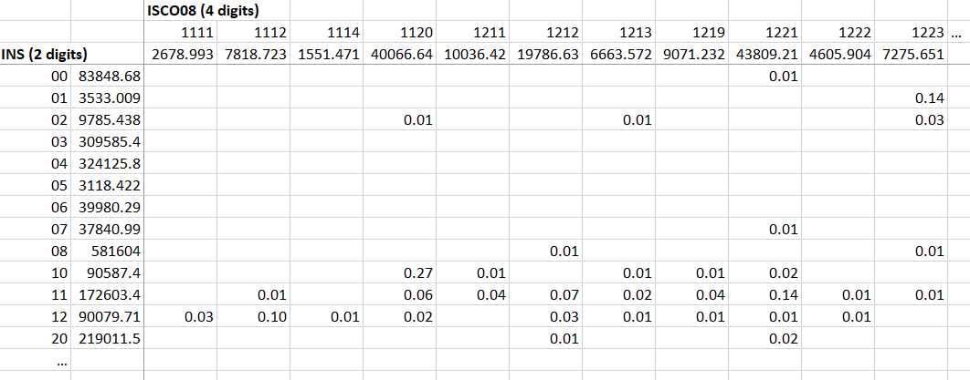
Note: Shares below 1% are not shown in the figure.
- We then apply the transition matrix to the entire period 1986 to 2010 in order to backward-extrapolate the occupational distribution according to the ISCO08 classification. Mathematically, this means that we multiply the (transposed) transition matrix with another matrix containing the number of workers in each INS group in each year between 1986 and 2010 (part of this matrix is shown in Figure C2) to obtain the estimated employment distribution in terms of ISCO08. For example, employment in ISCO08 group 1120 in 1986 is obtained by vector multiplying the “1120” column in Figure C1 with the “1986” column in Figure C2 (that is, multiply employment in NIS group 02 (5505) by 1%, employment in NIS group 10 (59872) by 27%, … and then adding these products).
Figure C2. Matrix with employment by INS (2 digits) for the period 1986-2010
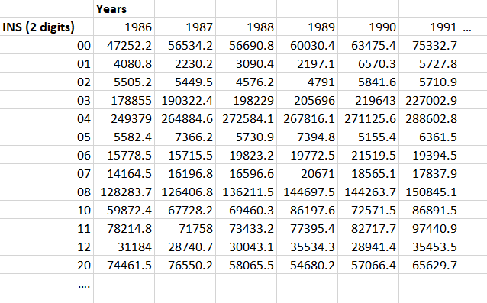
This procedure results in a harmonized times series according to the ISCO08 classification for the entire period 1986-2020. In this harmonized time series, data for the years 2011-2020 are based on directly observed ISCO08 codes, data for 2010 is largely based on post-hoc coding by researchers and data for the preceding years 1986-2009 are estimated based on the NIS codes and the estimated transition matrix. Thus, the main assumption of this methodology is that we assume that the distribution of NIS categories across ISCO08 categories was constant over the period 1986-2010.
Other assumptions have been made to estimate the transition matrix. First, we had to exclude the population that could not be recorded in ISCO08 by Statbel in 2010 from this harmonization exercise (10.8 percent of the employed population in 2010). In other words, we assume that the distribution over ISCO08 occupations for the population that was not recorded by Statbel is identical to the observed distribution for the recorded population. Next, the ISCO08 group 4419 (“Clerical support workers not elsewhere classified”) was removed from the analysis because it has a significant employment share in almost every INS group. Apparently, this ISCO08 group has been used as default when no sufficient information was available on the INS group to find its corresponding ISCO08 group. That is, “too many” workers were attributed to this group in 2010 and harmonizing the series including this group resulted in a huge drop at the time of the break in major group 4. The shares for this group are better be categorized as ‘not coded’ were given to that group. Finally, the armed forces occupation was removed from the analysis because no INS code refer to that group. Indeed, this groups was recorded as missing in our dataset hence we could not distinguish the different armed forces occupations from other missing values.
Note that, the transition matrix has been re-calculated when studying the relations between occupational change and worker characteristics by restricting the sample to the subgroup that is being studied. For example, when looking at the gender difference in occupational evolution, we first restricted the sample to the male or female sample and then re-run steps 1 and 2 to obtain harmonized occupational time series for men or women, respectively.
When using the Eurostat this harmonization could not be achieved because we do not have information about two classifications simultaneously in one year. Yet, at the 1 digit the groups between ISCO88 and ISCO08 are nominally identical (Table 2.5) , hence, we do not make any correction and harmonize the two classifications directly at the 1 digit. This is not perfect because even so the two classifications are nominally identical, there is in fact changes in the variable contents. Indeed, some of the changes at the more detailed level involve that minor groups are shifted between major groups: despite nominal equivalence at the major and sub-major level, this implies changes in underlying contents. The reader should therefore know that jumps between 2010 and 2011 in the EU-LFS survey may be the result of the change in nomenclature rather than an actual employment change.

Table C3. ISCO classification at the 1 digit level
 | ISCO88  (1 digit) | ISCO08  (1 digit)
1 | Legislators, senior officials and managers | Managers
2 | Professionals | Professionals
3 | Technicians and associate professionals | Technicians and associate professionals
4 | Clerks | Clerical support workers
5 | Service workers and shop and market sales workers | Service and sales workers
6 | Skilled agricultural and fishery workers | Skilled agricultural, forestry and fishery workers
7 | Craft and related trades workers | Craft and related trades workers
8 | Plant and machine operators and assemblers | Plant and machine operators, and assemblers
9 | Elementary occupations | Elementary occupations
0 | Armed forces | Armed forces occupations

Table C4. Correspondence table between INS81 and INS91 (2 digits)
Common denominator  “INS 2 digits” | Description | INS81 (2 digits) | INS91 (2 digits)
0. PROFESSIONS SCIENTIFIQUES, LIBERALES ET ASSIMILEES & 5. TECHNICIENS
00 | ARCHITECTES, INGENIEURS ET GEOMETRES | 00 | 00
01 | CHIMISTES, PHYSICIENS ET SPECIALISTES EN PHYSICO-CHIMIE | 01 | 01
02 | BIOLOGISTES, VETERINAIRES, AGRONOMES ET SPECIAL. ASSIMILES | 02 | 02  53
03 | - MEDECINS, ASSIMILES ET CADRE INFIRMIER  - AIDE-PHARMACIENS  - PERSONNEL SOIGNANT NON DIPLOMES  - TECHNICIENS PARAMEDICAUX | 03 | 03  54; 55; 56
04 | PERSONNEL DE L'ENSEIGNEMENT  PROFESSIONS INTERMEDIAIRES DE L'ENSEIGNEMENT | 04 | 04  58
05 | MINISTRES DU CULTE, MEMBRES DU CLERGE | 05 | 05
06 | PROFESSIONS JURIDIQUES | 06 | 06
07 | ARTISTES, ECRIVAINS, JOURNALISTES ET ASSIMILES | 07 | 07
08 | - SPECIALISTES DES FONCTIONS ADMINISTRATIVES + PERSONNES EXERCANT UNE PROF. LIBERALE, SCIENTIFIQUE N.C.A.  - PERSONNES EXERCANT UNE PROF. LIBERALE, SCIENTIFIQUE N.C.A.  - DESSINATEURS  - CHIMISTES NON UNIVERSITAIRES  - TECHNICIENS DE L'INFORMATIQUE  - AUTRES TECHNICIENS N.C.A. | 09  70 | 08  09  51; 52; 57; 59
1. CHEFS D'ENTREPRISE, PROPRIETAIRES-EXPLOITANTS, DIRECTEURS
10 | CHEFS D'ENTREPRISE (PRIVE) NON LIE PAR CONTRAT (SAUF 0.6) | 10 | 10
11 | DIRECTEURS ET CADRES (PRIVE) LIES PAR CONTRAT (SAUF 0,6) | 11 | 11
12 | DIRECTEURS ET CADRES DE L'ADMINISTRATION PUBLIQUE | 12 | 12
2. EMPLOYES DE BUREAU
20 | - AIDES-COMPTABLES, CAISSIERS, DACTYLOGRAPHES ET OPERATEURS  - AUTRES EMPLOYES N.C.A | 20 | 20  22
21 | EMPLOYES | 21 | 21
3. COMMERCANTS, PERSONNEL COMMERCIAL, VENDEURS ET ASSIMILES
30 | COMMERCANTS | 30 | 30
31 | AGENTS D'ASSURANCES, IMMOBILIERS, DE VENTE DE SERVICES | 31 | 31
32 | VOYAGEURS ET REPRESENTANTS DE COMMERCE | 32 | 32
33 | VENDEURS ET TRAVAILLEURS ASSIMILES | 33 | 33
40 | DIRECTEURS ET CHEFS D'EXPLOITATIONS AGRICOLES, HORTICOLES | 40 | 40
41 | AGRICULTEURS, HORTICULTEURS ET ELEVEURS NON LIE PAR CONTRAT | 41 | 41
42 | TRAVAILLEURS DANS L'AGRICULTURE, L'HORTICULTURE ET L'ELEVAGE | 42 | 42
43 | PECHEURS ET TRAVAILLEURS ASSIMILES | 43 | 43
44 | BUCHERONS ET AUTRES TRAVAILLEURS FORESTIERS | 44 | 44
6. PROFESSIONS DES TRANSPORTS ET DES COMMUNICATIONS
60 | OFFICIERS, PILOTES ET COMMANDANTS DE BATEAU | 60 | 60
61 | MATELOTS ET MACHINISTES DE NAVIRE (NAVI. MARI. ET FLUVIALE) | 61 | 61
62 | PILOTES D'AVION, NAVIGATEURS ET MECANICIENS DE BORD | 62 | 62
63 | CONDUCTEURS ET CHAUFFEURS (TRANSPORTS PAR RAIL ET PAR ROUTE) | 63 | 63
64 | INSPECTEURS, CONTROLEURS (TRANSPORTS) | 64 | 64
65 | AUTRES TRAVAILLEURS DES TRANSPORTS N.C.A. | 65 | 65
66 | TRAVAILLEURS DES COMMUNICATIONS N.C.A. | 66 | 66
7. ARTISANS, OUVRIERS DE METIER, A LA PRODUCTION ET MANOEUVRES
70 | MINEURS, CARRIERS ET TRAVAILLEURS ASSIMILES | 50 | 70
71 | FILEURS, TISSERANDS, TRICOTEURS, TEINTURIERS ET ASSIMILES | 71 | 71
72 | TAILLEURS, COUPEURS, FOUREURS ET ASSIMILES | 72 | 72
73 | CORDONNIERS ET AUTRES TRAVAILLEURS DU CUIR | 73 | 73
74 | CONDUCTEURS DE FOUR, LAMINOIR, TREFILEURS, MOULEURS ET ASSI. | 74 | 74
75 | MECANICIENS EN INSTRUMENTS, HORLOGERS, ORFEVRES ET ASSIMILES | 75 | 75
76 | AJUSTEURS, OUTILLEURS, PLOMBIERS, SOUDEURS, TOLIERS ET ASSI. | 76 | 76
77 | ELECTRICIENS ET ASSIMILES | 77 | 77
78 | CHARPENTIERS, MENUISIERS, EBENISTES, TRAVAILLEURS DU BOIS | 78 | 78
79 | PEINTRES, COLLEURS DE PAPIERS PEINTS ET ASSIMILES | 79 | 79
8. ARTISANS, OUVRIERS DE METIER, A LA PRODUCTION ET MANOEUVRES
80 | OUVRIERS ET ARTISANS DE LA CONSTRUCTION | 80 | 80
81 | TRAVAILLEURS DE L'IMPRIMERIE, DE L'EDITION ET DE LA RELIURE | 81 | 81
82 | VERRIERS, POTIERS, AUTRES TRAVAILLEURS DU VERRE ET CERAMIQUE | 82 | 82
83 | TRAVAILLEURS DE L'INDUSTRIE ALIMENTAIRE | 83 | 83
84 | TRAVAILLEURS DE L'INDUSTRIE CHIMIQUE ET DU PAPIER | 84 | 84
85 | OUVRIERS ET TRAVAILLEURS ASSIMILES EN TABAC | 85 | 85
86 | ARTISANS, OUVRIERS DE METIER ET OUVRIERS A LA PRODUCTION NCA | 86 | 86
87 | EMBALLEURS, CAPSULEURS, ETIQUETEURS ET ASSIMILES | 87 | 87
88 | CONDUCTEURS DE MACHINES FIXES, D'EXCAVATION ET DE LAVAGE | 88 | 88
89 | DOCKERS ET MANUTENTIONNAIRES, MANOEUVRES N.C.A. | 89 | 89
9. TRAVAILLEURS DES SERVICES, SPORTS ET ACTIVITES RECREATIVES
90 | POMPIERS, POLICIERS, GARDIENS ET ASSIMILES | 90 | 90
91 | PERSONNEL DES SERVICES DOMESTIQUES, HORECA,... | 91 | 91
92 | TRAVAILLEURS DES SERVICES PERSONNELS | 92 | 92
93 | ATHLETES, SPORTIFS ET ASSIMILES | 93 | 93
94 | AUTRES PROFESSIONS DES SERVICES | 94 | 94
Appendix D. Sectoral and occupational change in Belgium and its neighboring countries

Figure D1. Sectors’ share evolution in Belgium and its neighboring countries (1995-2018)
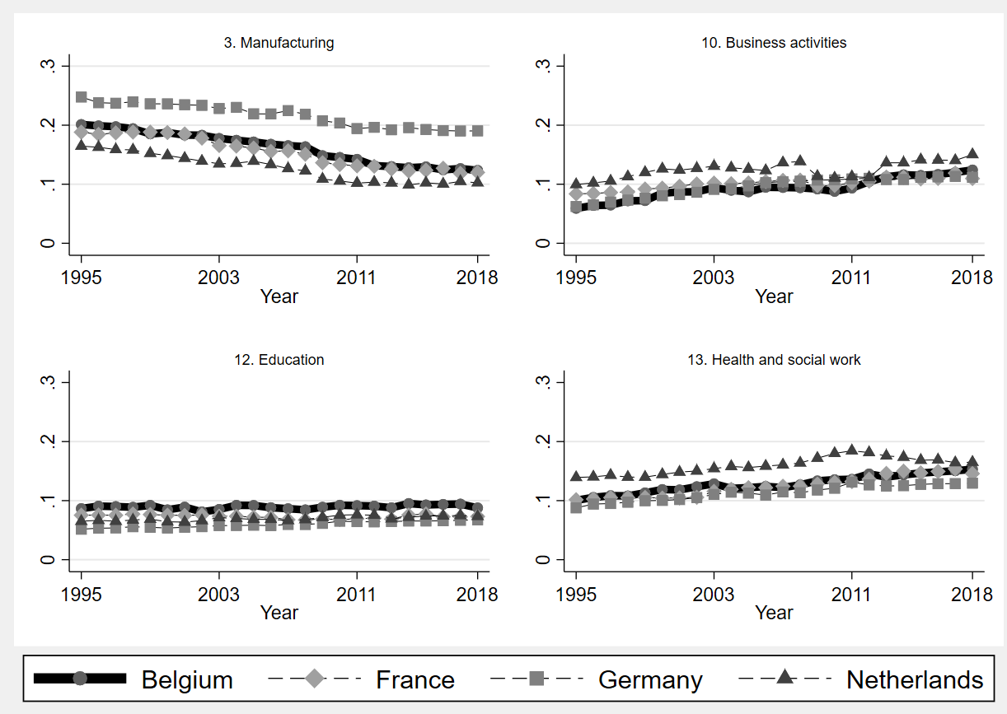

Figure D2. Occupations’ share evolution in Belgium and its neighboring countries (1995-2018)
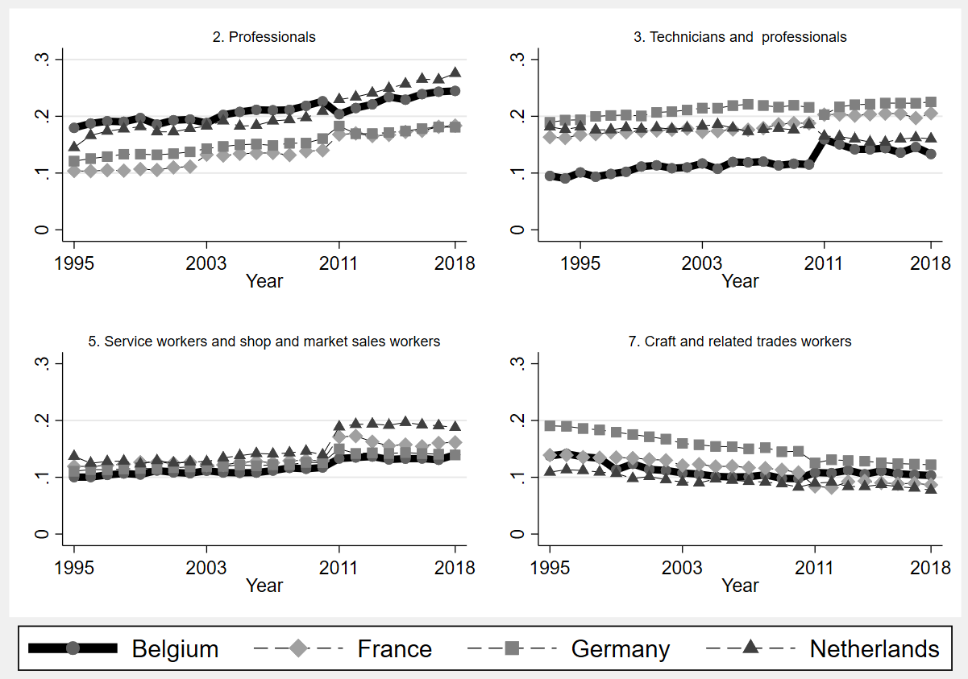

Appendix E. Correspondence tables for the job polarization analyses
Correspondence table for high, middle-high, middle-low and low skill occupations
High-paying occupations are
- Chief executives, senior officials and legislators
- Administrative and commercial managers
- Production and specialized services managers
- Science and engineering professionals
- Health professionals
- Teaching professionals
- Business and administration professionals
- Information and communications technology professionals
- Legal, social and cultural professionals
Middle-high paying jobs are
- Hospitality, retail and other services managers
- Science and engineering associate professionals
- Health associate professionals
- Business and administration associate professionals
- Legal, social, cultural and related associate professionals
- Information and communications technicians
Middle-Low paying jobs are
- General and keyboard clerks
- Customer services clerks
- Numerical and material recording clerks
- Other clerical support workers
- Personal service workers
- Sales workers
- Personal care workers
- Protective services workers
- Market-oriented skilled agricultural workers
- Market-oriented skilled forestry, fishery and hunting workers
- Subsistence farmers, fishers, hunters and gatherers
- Building and related trades workers, excluding electricians
- Metal, machinery and related trades workers
- Handicraft and printing workers
- Electrical and electronic trades workers
- Food processing, wood working, garment and other craft and related trades workers
- Stationary plant and machine operators
- Assemblers
- Drivers and mobile plant operators
Low paying occupation
- Cleaners and helpers
- Agricultural, forestry and fishery labourers
- Laborers in mining, construction, manufacturing and transport
- Food preparation assistants
- Street and related sales and service workers
- Refuse workers and other elementary workers

Correspondence table for manual, routine and abstract occupations

Manual occupations are
- 53. personal care,
- 75. Food services
- 91. Cleaning service
- 54. protective services.
Routine occupations are
- 81. Operators
- 92-93. Laborers, production,
- 4. office/administrative
- 52. sales.
Abstract occupations are
- 3. technicians,
- 2. professionals
- 1. managers.
Appendix F – Transition matrices between occupations and non-employment

Table F1. Transitions between ISCO-08 1 digit occupations and non-employment, 2012-2018
 | Status in year t
Status in year t-1 | Same  occupation | Other  occupations | Non-  employment | Total
Armed forces | 92.52% | 1.36% | 6.12% | 100.00%
Other occupations | 0.00% | 93.56% | 6.44% | 100.00%
Non-employment | 0.01% | 6.06% | 93.93% | 100.00%
Managers | 91.09% | 3.64% | 5.27% | 100.00%
Other occupations | 0.28% | 92.92% | 6.80% | 100.00%
Non-employment | 0.22% | 5.86% | 93.93% | 100.00%
Professionals | 93.61% | 1.78% | 4.62% | 100.00%
Other occupations | 0.67% | 91.65% | 7.68% | 100.00%
Non-employment | 1.25% | 4.83% | 93.93% | 100.00%
Technicians and associate prof. | 88.50% | 4.33% | 7.18% | 100.00%
Other occupations | 0.51% | 92.42% | 7.07% | 100.00%
Non-employment | 0.66% | 5.41% | 93.93% | 100.00%
Clerks | 88.36% | 3.46% | 8.18% | 100.00%
Other occupations | 0.42% | 92.87% | 6.70% | 100.00%
Non-employment | 0.67% | 5.40% | 93.93% | 100.00%
Service and sales workers | 85.17% | 2.89% | 11.94% | 100.00%
Other occupations | 0.36% | 93.57% | 6.07% | 100.00%
Non-employment | 1.23% | 4.84% | 93.93% | 100.00%
Skilled agricultural and fishery workers | 87.85% | 1.21% | 10.93% | 100.00%
Other occupations | 0.01% | 93.59% | 6.40% | 100.00%
Non-employment | 0.07% | 6.00% | 93.93% | 100.00%
Craft and related trades workers | 88.29% | 2.69% | 9.02% | 100.00%
Other occupations | 0.20% | 93.39% | 6.41% | 100.00%
Non-employment | 0.58% | 5.50% | 93.93% | 100.00%
Plant and machine operators and assemblers | 86.13% | 4.83% | 9.03% | 100.00%
Other occupations | 0.18% | 93.39% | 6.43% | 100.00%
Non-employment | 0.34% | 5.73% | 93.93% | 100.00%
Elementary occupations | 82.82% | 3.23% | 13.95% | 100.00%
Other occupations | 0.26% | 93.74% | 6.00% | 100.00%
Non-employment | 1.04% | 5.03% | 93.93% | 100.00%
Note: EU-SILC data 2012-2019. N=21,195 (see Table 19 for sub-sample sizes).

