The restructuring of the Belgian labour market, 1986-2020:
Sectoral and occupational change, job polarization, mobility, and worker characteristics
Nick Deschacht & Céline Detilleux
KU Leuven – Department of Economics

1. Introduction
Technological change affects labour markets by changing the occupational structure, meaning that the share of workers in some occupations declines while the share of workers in other occupations grows. The aim of this paper is to study longer-term trends in occupational change in Belgium and by focusing on four research objectives: (1) to describe the extent of sectoral and occupational change in the Belgian labour market over the past decades; (2) to describe how these changes are related to worker characteristics such as gender, skills, age and geographical space; (3) to investigate the extent of job polarization in the Belgian labour market (i.e. the disappearance of middle-skill routine jobs), and (4) to describe occupational mobility by studying transitions of workers between occupations.
Studying longer-term occupational change is important because the diffusion of new technologies and their impact on labour markets occurs gradually and it often takes decades before clear changes are realized at the level of aggregate labour market statistics, while this type of empirical evidence is required to improve our theoretical understanding of how technology affects labour markets. Understanding how these effects differ by worker characteristics is important to understand trends in inequality in the labour market, such as overall wage inequality and skill premiums, gender gaps, the difficulties faced by older workers, as well as the role of cities and urban centres in reinforcing or dampening these trends and inequalities. The main mechanism that allows labour markets to cope with mismatches arising from occupational change, is the moving of workers from declining to growing occupations. Studying the determinants of this occupational mobility is important to better understand the opportunities and the threats of occupational change to labour markets.
The theoretical debate about the effects of technology and the digital revolution on labour markets can be summarized as follows (for a detailed review see Deschacht, 2021). Although the digital revolution has led to fears of substantial job losses and unemployment because of automation, economic theory suggests that technological change also leads to job growth in certain occupations because (1) more workers are needed to build and operate these new technologies, (2) product prices tend to fall as a result of technological change and increasing productivity which tends to increase the demand for products and workers in sectors undergoing these technological changes, and (3) growing productivity in some sectors increases incomes and the demand for products and workers in other and new sectors of the economy. The effects of the digital revolution on labour demand are likely to differ by skills (skill-biased technological change), for example if new technologies automate mostly unskilled labour and require more skilled labour to operate them. However, empirical evidence suggests that technological change is routine-biased, rather than skill-biased, whereby routine jobs – which tend to be middle-skilled – are automated so that the shares of both low-skilled and high-skilled jobs tend to rise over time (job polarization). The effects could differ by gender because women more often work in occupations that require in-person interactions, such as health workers, that are less likely to be substituted by new technologies. The digital revolution poses specific challenges for older workers, because they invest less in human capital and because organizations invest less in older workers, so they are more likely to lack the skills to adjust to the changing work tasks in their job resulting from the digital revolution. The spatial structure and the way jobs and workers are located geographically also matters, for example if job growth is mainly concentrated in cities and their peripheries. Because the digital revolution leads to changes in the occupational distribution, workers may have to move from declining occupations to growing occupations. However, such occupational mobility may be difficult for older and experienced workers who accumulated firm and occupation specific human capital over their careers, so that a job change might lower their productivity and income.
This paper contributes to the literature in a number of ways. First, we provide fresh and detailed estimates of occupational changes that have been taking place over the past 35 years, and of how these changes intersect with skills, gender, age and geographical space. Second, we contribute to the methodological literature on the harmonization of occupational classifications over time. Studying longer-term occupational trends is challenging because occupational classifications change over time to account for the emergence of new occupations and to account for the changing task composition of occupations. We adopt a method of statistical harmonization which allows us to backward-extrapolate the occupational structure in time and to create consistent time-series spanning various decades.
The remainder of this paper is organized as follows. Section 2 discusses the various data sources, the methods and our approach to harmonize occupational classifications over time. Section 3 presents the results, starting with a brief sketch of the evolution of Belgian labour supply over the past 35 years, followed by a detailed discussion of sectoral and occupational changes, an analysis of job polarization in the Belgian labour market, and ending with an analysis of the determinants of occupational mobility. Section 4 concludes and discusses the main findings.

2. Data and methods
Data
Three datasets were used to carry out the analyses:
- The “Enquête sur les forces de travail/ Enquête naar de arbeidskrachten” (EAK), the Belgian Labour force Survey, obtained from the Belgian statistical office Statbel.
- The “European Labour Force Survey” (EU-LFS) obtained from Eurostat.
- The “EU Statistics on Income and Living Conditions” (EU-SILC) obtained from Eurostat.
All three data sets use sampling methods that allow for representativity of the samples for the employed population. The EAK data are essentially equivalent to the Belgian respondents in the EU-LFS since the data published by Eurostat are computed from the EAK data they receive from Statbel. However, there are some differences (explained in appendix A) which led us to use the EAK data for the main analyses. The EU-LFS data are only used when we compare Belgium and its neighbouring countries. The EAK covers the period 1983-2020, but since information on occupations is only available from 1986 on, we restricted the analysis to the period 1986- 2020. For the same reasons, we further restricted the sample to the period 1993- 2018 when working with the EU-LFS dataset. The EU-SILC data are longitudinal data for the period 2012-2020 and are used to study transitions of workers across occupations. The numbers of workers reported in this study always refer to the numbers of workers in the population, which are estimated by reweighting the sample (see Appendix A). The effective sample size of the EAK survey is 27,914 workers in 1986, 62,106 workers in 2020 and 1,385,729 workers for the entire period 1986-2020.
We restrict the analysis to the employed population aged 15 and older. The employed population refers to persons who indicate in the survey that they worked for at least one hour during a given week (the ILO definition) – be they salaried, self-employed, paid interns, helpers in a family business or persons who have a job but who are temporarily absent for reasons such as sickness (less than one year) or paid leave.
Age is reported in four categories: strictly younger than 30 years old (the minimum is 15), 30 or older and younger than 40, 40 or older and younger than 50, and 50 or older (the maximum is 96). Our educational variable contains three categories: low-educated (no high school degree), middle-educated (high school degree) and high-educated (tertiary education degree). The regional variable refers to the region of the workplace (not the place of residence of the worker) and contains four categories: Brussels, Flanders, Wallonia and abroad.
Harmonization methods
The sectors and occupations of workers in the EAK and EU-LFS data are measured using classifications that have gone through several changes and revisions over time. These changes were implemented to account for the emergence of new products and occupations, for the changing task content of occupations (for example an occupation that evolves to require more responsibilities and skills is regrouped with occupations that require similar skills), or in an attempt to make classifications more comparable across countries. Every change of a classification leads to breaks in the time series, which complicates the study of changes over time. To study how the distribution of workers across sectors and occupations has changed over time, it is necessary to harmonize the different classifications to obtain consistent time series of sectoral and occupational information.
The most appropriate method to harmonize two classifications (we refer to them as the old classification and the new classification) depends on the specific changes that were introduced, i.e. on the nature of the relation between the categories in both classifications. In the simplest situation there is a 1-to-1 correspondence between the categories (a bijective function), which implies a correspondence table that allows for the conversion of the old categories to the new categories. If some categories of the old classification were combined into one category in the new classification (an injective function), then the new classification can be used as the harmonized classification and the old categories can be converted into the new categories by means of a many-to-1 correspondence table.
More complicated situations with many-to-many relationships between the categories require other harmonization approaches. One approach is the aggregation of the categories in the old and new classifications so that a 1-to-1 mapping becomes possible between the aggregated categories. However, aggregation inevitably reduces the level of measurement detail, with information being lost in the harmonized classification.
In some cases, exact harmonization via aggregation is undesirable because too much information would be lost. For some occupational classifications, exact harmonization would even require that all the categories be merged into a single category so that all information would be lost (for example when an occupation in the old classification is split over many categories in the new classification). In those cases it is better to abandon the objective of an exact harmonization by either dropping certain categories from the harmonization (‘incomplete harmonization’) or by approximating the relation between the two classifications in a way that allows for harmonization so that the number of observations in a category is estimated, relying on certain assumptions, rather than being observed (we refer to this method as ‘statistical harmonization’). For example, if an occupation in the old classificiation is split into two groups A and B in the new classification and if we know that almost all workers end up in group A, then a harmonization could be done by assuming that all workers move to group A or by calculating exactly how workers are redistributed into the two groups and use these estimated shares to reclassify the workers.

Harmonization of the sectoral data
Sectors in the EAK and the EU-LFS datasets are defined based on NACE classifications. Over the years, the NACE classification has gone through several revisions which results in a number of breaks in our sectoral data (Table 1):
Table 1. Sectoral classifications in the EAK and EU-LFS, 1986-2020
Year | 86 |  |  |  | 90 |  |  |  |  | 95 |  |  |  |  | 00 |  |  |  |  | 05 |  |  |  |  | 10 |  |  |  |  | 15 |  |  |  |  | 20
EAK | NACE 70  (3 digits) |  |  |  |  |  |  | NACE-BEL 93  (3 digits) |  |  |  |  |  | NACE-BEL 2003  (2 digits) |  |  |  |  |  |  |  |  | ª |  | NACE-BEL 2008  (2 digits)
EU-LFS |  |  |  |  |  |  | NACE Rev. 1  (1 digits) |  |  |  |  |  |  |  |  |  |  |  |  |  |  |  |  | NACE Rev. 2  (1 digits)
Notes: ª In 2008 and 2009 the EAK contains both NACE-BEL 2003 (2 digits) and NACE-BEL 2008 (2 digits).

In the EAK data, we harmonized NACE-BEL 2003 and NACE-BEL 2008 (which are equivalent to NACE Rev. 1.1 and Rev 2 respectively) using aggregation and following Eurostat (2008). Harmonizing with NACE-BEL 93 was straightforward because at the 2-digit level NACE-BEL 93 does not differ from NACE-BEL 2003. Harmonizing the data for the period before 1992 required an approximation and additional assumptions: in case of 1-to-many relations we used the NACE-BEL 1993 category that most frequently appears as a correspondence of a NACE 70 category. More details about the sectoral harmonization and the correspondence tables we constructed are included in Appendix B.

Harmonization of the occupational data
The occupational classifications in the EAK and the EU-LFS have encountered several breaks over time as well, which complicates the construction of homogeneous times series (see Table 2). The occupations of workers in the EAK were coded using the national NIS classification of the Belgian statistical office Statbel between 1986 and 2010, and using the International Standard Classification of Occupations (ISCO) classification between 2011 and 2020. The NIS81 and NIS91 for the period 1986-2010 were harmonized using aggregation (see Appendix C for more details and the resulting correspondence table).

Table 2. Occupational classifications in the EAK and EU-LFS, 1986-2020
Year | 86 |  |  |  | 90 |  |  |  |  | 95 |  |  |  |  | 00 |  |  |  |  | 05 |  |  |  |  | 10 |  |  |  |  | 15 |  |  |  |  | 20
EAK | NIS81 (3 digits) |  |  |  |  |  |  | NIS91 (3 digits)  (pseudo-coded to ISCO88 3 digits) |  |  |  |  |  |  |  |  |  |  |  |  |  |  |  |  | ª | ISCO08 (4 digits)^{b}
EU-LFS |  |  |  |  |  |  |  | ISCO88 (3 digits) |  |  |  |  |  |  |  |  |  |  |  |  |  |  |  |  | ISCO08 (3 digits)
Notes: ª For 2010 the EAK contains both the surveyed NIS91 (3 digits), pseudo-coded ISCO88 (3 digits) and post-hoc coded ISCO08 (4 digits). ^{b} In 2011 ISCO08 only contains 3 digits in the EAK.

The major break in the occupational classifications occurs in 2011 and corresponds to the introduction of the ISCO08 classification in the Labour Force Survey in many European countries. The revision of ISCO88 was necessary because economic changes during the 20 years between the two classifications, such as the adoption of new information and communications technologies, required a re-definition of the occupational classification (ILO, 2012).
In countries where ISCO88 had been consistently used, harmonization with the new ISCO08 is feasible using the ILO correspondence table (ILO, 2012). However, the case of Belgium is particularly challenging since ISCO88 codes were never used directly in the Belgian version of the Labour Force Survey (EAK). Until 2010, the coding of occupations in the EAK was done using the Belgian NIS classification. The NIS codes were subsequently mapped (“pseudo-coding”) onto ISCO88 at three-digit level using a one-to-one correspondence table NIS-ISCO88 (3 digits) that has remained fixed over time, but was only an approximation of what would have resulted from a direct coding of occupations following ISCO88-rules (Mucaj, 2017). Because of this pseudo-coding procedure, using the ILO correspondence table from ISCO88 to ISCO08 (Ganzeboom, 2019; Jann, 2019) leads to very poor results in the case of Belgian data.
An exact harmonization of NIS and ISCO codes via aggregation proved to be undesirable because too much information would be lost. Thus, we adopted a statistical harmonization approach. Fortunately, for the 2010 EAK data the Belgian statistical office Statbel has recoded the descriptive information regarding occupations in the survey into ISCO08 unit groups. So, the EAK data for the year 2010 contain occupational information both in terms of the surveyed NIS codes and post-hoc coded ISCO08 codes.
We rely on these 2010 EAK data and build on a statistical harmonization method that was developed at the Federal Planning Bureau and described in Muçaj (2017). We first calculate how employment in each NIS 2 digits category is distributed over the ISCO08 categories in 2010, which results in a transition matrix between NIS and ISCO08 codes. Next, we apply the transition matrix to the entire period 1986 to 2010 in order to backward-extrapolate the ISCO08 occupational distribution. Appendix C contains a more detailed description of the estimation procedure. This procedure results in a harmonized times series according to the ISCO08 classification for the entire period 1986-2020. In this harmonized time series, data for the years 2011-2020 are based on directly observed ISCO08 codes, data for 2010 are based on post-hoc coding by researchers and data for the preceding years 1986-2009 are estimated based on the NIS codes and the estimated transition matrix for 2010.
When studying the relationship between occupational change and worker characteristics, the transition matrix is re-estimated for the specific group under consideration. For example, when looking at gender differences in occupational change, we estimate a transition matrix for the male workers in 2010 to harmonize the male occupational data and a separate transition matrix for the female workers to harmonize the female occupational data.
This estimation procedure has a number of weaknesses and it relies on certain assumptions. First, the Statbel recoding effort for the 2010 data failed to assign an ISCO08 code for 10.8 percent of the employed population. Since we have to exclude these workers from the analysis, we are in fact assuming that the distribution over ISCO08 occupations for the population that was not recoded is identical to the distribution for the recoded population. Second, the armed forces occupation and ISCO08 group 4419 (“Clerical support workers not elsewhere classified”) were removed from the analysis. The latter group was used as a default group during the Statbel recoding effort so that including this group results in serious overestimations and discontinuities of the time series between 2010 and 2011 (see Appendix C and Muçaj, 2017). The armed forces occupation was removed because it was not contained in the NIS classification. Third, since the transition matrix is estimated based on 2010 data only, we assume that the distribution of NIS categories across ISCO08 categories was constant over the period 1986-2010, which might lead to an overestimation of past shares of new/growing occupations (such as occupations in ICT).

Statistical methods
This report mainly presents descriptive statistics (frequency tables and graphs), as well as the results of linear regression analyses where an evaluation of the statistical significance of the estimated effects is useful (particularly for the EU-SILC data where the sample sizes are more limited). To analyse how much the sectoral and occupational structure has changed between 1986 and 2020 for various groups in the labour market, we calculate Dissimilarity Indices because they can be given a clear interpretation: the index ranges between 0 and 1 and it can be interpreted as the percentage of workers than would need to change sectors or occupations in 1986 in order to arrive at the sectoral or occupational distribution in 2020. In other words, the Dissimilarity Index can be interpreted as a measure for the degree of turbulence in a particular labour market. Formally, it is calculated as half of the sum of the absolute differences between the employment shares in 1986 and 2020.
The EU-SILC longitudinal data for the period 2012-2020 are used to study worker flows across occupations. We distinguish between three transitions: staying in the same (ISCO 1-digit) occupation, moving to another (ISCO 1-digit) occupation, and moving to non-employment. We define a transition to another occupation using an indicator variable that takes the value 1 when the ISCO-08 category at the 1-digit level of aggregation of a respondent differs from the ISCO category the year before (so we study year-to-year transitions). In order to limit the problem of false transitions, which is common in this type of approach, the indicator variable only takes the value 1 if the change in the ISCO code is accompanied by a job change (the respondent is asked whether (s)he changed jobs over the past year). A transition to non-employment is defined using an indicator variable for a change in activity status from employment to non-employment. Staying in the same occupation is an indicator variable that takes the value 1 when the individual did not make a transition to another occupation nor to non-employment.

3. Results
3.1. Evolution of the employed population
Figure 1 and Table 3 describe the evolution of the employed population in Belgium. Between 1986 and 2020, the total number of workers has increased by 36 percent. This growth can almost entirely be attributed to the increasing employment of women, who now account for almost half of the employed population. The composition of the employed population in terms of skills and age has drastically changed as well. The number of low-educated workers (without a high school degree) has fallen by 66 percent, whereas the number of high-educated workers (with a degree in tertiary education) has more than tripled. The number of young workers (younger than 30) has fallen by 21 percent, whereas the number of older workers (older than 50) has more than doubled.
Figure 1: Employed population in Belgium, 1986-2020
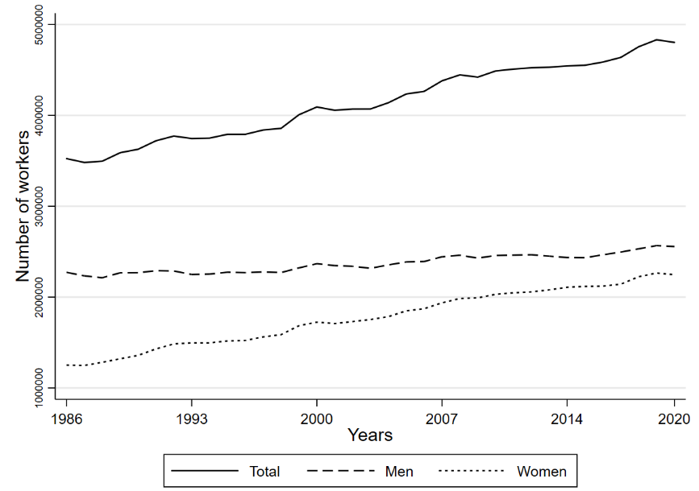

Table 3: Employed population by gender, education, age and region
 | 1986 |  | 2020 |  | Growth
 | Workers | Percent | Workers | Percent | 1986-2020
Total | 3,524,079 | 100% | 4,802,984 | 100% | 36.3%
Gender
Men | 2,272,647 | 64% | 2,556,697 | 53% | 12.5%
Women | 1,251,432 | 36% | 2,246,287 | 47% | 79.5%
Education
Low | 1,898,321 | 54% | 653,101 | 14% | -65.6%
Middle | 893,467 | 25% | 1,819,567 | 38% | 103.7%
High | 732,290 | 21% | 2,330,316 | 49% | 218.2%
Age
<30 | 1,091,322 | 31% | 866,327 | 18% | -20.6%
[30-40[ | 1,080,497 | 31% | 1,212,225 | 25% | 12.2%
[40-50[ | 743,384 | 21% | 1,237,913 | 26% | 66.5%
>=50 | 608,875 | 17% | 1,486,518 | 31% | 144.1%
Region
Brussels | 601,982 | 17% | 754,287 | 16% | 25.3%
Flanders | 1,906,437 | 54% | 2,725,007 | 57% | 42.9%
Wallonia | 952,929 | 27% | 1,200,345 | 25% | 26.0%
Abroad | 62,731 | 2% | 123,345 | 3% | 96.6%
Note: EAK data (see text for variable definitions and sample sizes). Region refers to the region of the workplace.

3.2 Sectoral change
Figure 2 shows the evolution of employment in each of the broad sectors of the Belgian economy. Employment in the tertiary and quaternary sectors has grown sharply, whereas employment in the secondary and primary sectors has fallen.

Figure 2. Number of workers by sector, 1986-2020
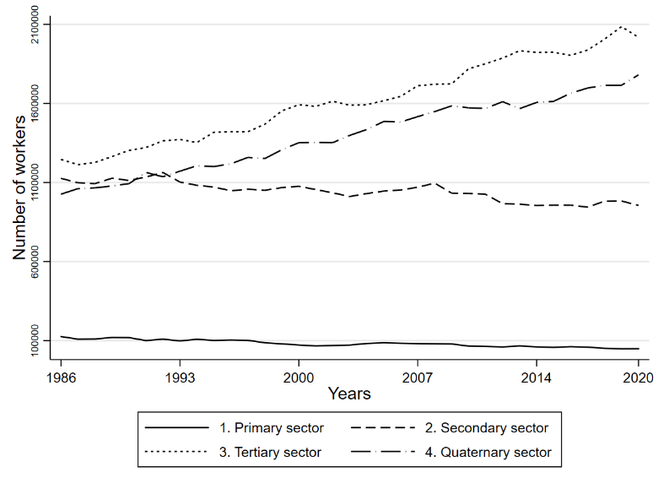
Table 4 presents the employment growth rates for each of the NACE sectors at the 1-digit level, and it compares the distribution of workers across sectors in 1986 and 2020. The number of jobs in the manufacturing sector has fallen by 32 percent and the share of manufacturing in total employment has halved from 25 percent in 1986 to 12 percent in 2020. Employment in health and social work has almost tripled and now accounts for over 15 percent of total employment. Employment has grown by almost a factor 5 in the broad category of business activities, which includes jobs in variety of sectors such as real estate, legal and accounting activities, consultancy, marketing, employment agencies, travel agencies, translation work, cleaning and security.

Table 4. Number of workers by sector (NACE 1 digit), 1986-2020
 | 1986 |  | 2020 |  | Growth
 | Workers | Percent | Workers | Percent | 1986-2020
1. Agriculture | 112,590 | 3,2% | 44,598 | 0,9% | -60.4%
2. Mining and quarrying | 23,882 | 0,7% | 4,189 | 0,1% | -82.5%
3. Manufacturing industries | 866,318 | 24,6% | 590,964 | 12,3% | -31.8%
4. Electricity/Water supply | 31,048 | 0,9% | 64,423 | 1,3% | 107.5%
5. Construction | 203,679 | 5,8% | 320,669 | 6,7% | 57.4%
6. Wholesale and retail trade | 549,263 | 15,6% | 594,052 | 12,4% | 8.2%
7. Hotels and restaurants | 105,784 | 3,0% | 158,124 | 3,3% | 49.5%
8. Transport/Communication | 255,959 | 7,3% | 432,396 | 9,0% | 68.9%
9. Financial intermediation | 142,986 | 4,1% | 154,676 | 3,2% | 8.2%
10. Business activities | 132,517 | 3,8% | 596,013 | 12,4% | 319.8%
11. Public administration | 345,546 | 9,8% | 405,139 | 8,4% | 17.2%
12. Education | 293,947 | 8,4% | 472,658 | 9,8% | 60.8%
13. Health and social work | 269,507 | 7,7% | 729,873 | 15,2% | 170.8%
14. Social/personal services | 165,527 | 4,7% | 183,284 | 3,8% | 10.7%
15. Other | 20,874 | 0,6% | 51,926 | 1,1% | 248.8%
Total | 3,512,305 | 100,0% | 4,802,984 | 100,0% | 36.7%
Note: EAK data

At a more detailed NACE 2-digit level it was not possible to harmonize the data for the entire 35-year period. However, tables 5 and 6 show the sectors that have grown/declined the most in the past decade (2010-2020). The largest employment growth (in absolute terms) has been in cleaning and security services, hospital and care work, computer programming and employment agencies. The largest drops in employment are concentrated in a number of manufacturing sectors, as well as in the agricultural sector.

Table 5. Sectors with the largest employment growth, 2010-2020 (NACE 2-digit)

NACE | Sector | Workers 2010 | Workers 2020 | Growth (workers) | Growth (%)
81 | Services to buildings (cleaning, security, …) | 73,332 | 118,782 | 45,450 | 62.0 %
88 | Social work for elderly and disabled | 154,460 | 196,347 | 41,887 | 27.1 %
87 | Residential care | 142,747 | 182,927 | 40,180 | 28.1 %
86 | Hospital and medical work | 310,972 | 350,600 | 39,627 | 12.7 %
62 | Computer programming | 70,292 | 105,726 | 35,435 | 50.4 %
78 | Employment agencies | 34,222 | 67,945 | 33,723 | 98.5 %
71 | Architectural and engineering activities | 42,548 | 69,696 | 27,148 | 63.8 %
69 | Legal and accounting activities | 65,625 | 85,494 | 19,869 | 30.3 %
68 | Real estate activities | 22,505 | 41,575 | 19,070 | 84.7 %
Note: EAK data

Table 6. Sectors with the largest decline in employment, 2010-2020 (NACE 2-digit)

NACE | Sector | Workers 2010 | Workers 2020 | Growth (workers) | Growth (%)
29 | Car manufacturing | 58697 | 38306 | -20391 | -34.7
25 | Metal manufacture | 63794 | 49633 | -14161 | -22.2
20 | Chemical sector | 56995 | 42944 | -14051 | -24.7
1 | Agriculture | 55458 | 43458 | -12000 | -21.6
53 | Postal work | 43148 | 34534 | -8613 | -20.0
Note: EAK data

Figure 3 compares the sectoral growth rates (percent growth rates, not in terms of the number of workers) in Belgium to the average growth rates in neighbouring countries France, Germany and The Netherlands. Most sectors are close to the 45° diagonal which implies that the industrial restructuring in Belgium is broadly in line with that of its neighbouring countries. The main difference is in the broad category of business activities (real estate, legal and accounting, cleaning and security,…) where employment has grown faster in Belgium than in the neighbouring countries. A more detailed analysis of the evolution of the employment shares of selected sectors in Belgium compared to its neighbouring countries confirms that the evolution is similar (see Appendix D).

Figure 3. Sectoral change in Belgium and neighbouring countries, 1995-2018 (EU-LFS)
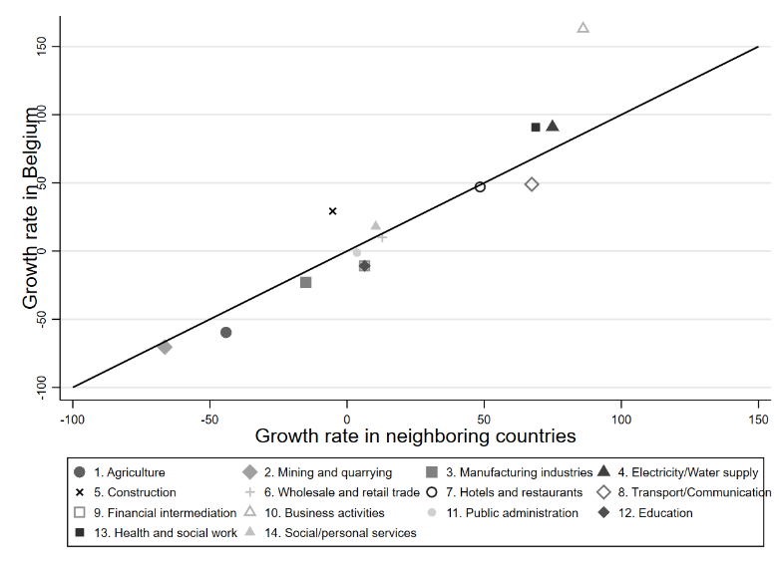

3.2 Sectoral change and worker characteristics
Tables 7, 8, 9 and 10 present sectoral employment shares in 1986 and 2020 by gender, educational level, age and region (of the workplace). For men, the share of manufacturing in total employment has dropped from 30 percent in 1986 to 18 percent in 2020. The share of business activities (real estate, legal and accounting, cleaning and security, …) in male employment has risen by almost 8 percentage points. The share of manufacturing employment has dropped substantially for women as well by almost 10 percentage points. Other large changes in female employment are the decline of retailing, and the rising shares of business activities and health and social work. Education and health and social work now account for over 40 percent of female employment.
High-skill workers used to be concentrated in the educational sector in 1986, but the share of education in high skilled-employment has dropped by over 13 percentage points by 2020. High-skilled workers are now more likely to work in business activities and the category of transport/communication (which includes ICT). Low-skill workers used to be concentrated in the manufacturing sector in 1986, but that share has dropped by over 15 percentage points. Greater shares of low-skill workers now work in business activities (which includes cleaning and security services) and health and social work. Middle-skill workers are now less likely to work in manufacturing as well, and the share of the financial sector in middle-skill employment has dropped substantially too. Greater shares of middle-skill workers now work in business activities, the construction industry and health and social work. The dissimilarity index suggests that the sectoral changes have been more turbulent for low-skill workers than for high-skill workers. Almost 25 percent of the low-skill workers would have to change sectors today in order to go back to the sectoral structure of 1986. For high-skill workers this is only 18 percent.
Table 9 reveals some interesting patterns about the relationship between sectoral changes and worker age. The declining share of agriculture is a story of workers older than 50. In 1986, over 7 percent of older workers still worked in agriculture, whereas in the younger age groups the declining share of agriculture had already taken place before 1986. The declining share of the retail sector is also concentrated among older workers. On the other hand, the declining share of work in public administrations is concentrated among younger workers, and the increasing share of health and social work is more pronounced for older workers.
Sectoral changes are largely similar across regions (Table 10), but there are some notable differences such as the larger drop in the shares of retailing and the financial sector in the (urban) region of Brussels.

Table 7. Sectoral employment shares by gender in 1986 and 2020 (NACE 1-digit)
 | Men |  |  | Women
 | 1986  (pct.) | 2020  (pct.) | Change (ppt.) | 1986  (pct.) | 2020  (pct.) | Change (ppt.)
1. Agriculture | 3.5 | 1.2 | -2.3 | 2.7 | 0.7 | -2.0
2. Mining and quarrying | 1.0 | 0.1 | -0.9 | 0.0 | 0.0 | -0.0
3. Manufacturing industries | 29.5 | 17.8 | -11.7 | 16.2 | 6.4 | -9.8
4. Electricity/Water supply | 1.3 | 2.0 | 0.7 | 0.2 | 0.6 | 0.4
5. Construction | 8.6 | 11.4 | 2.8 | 0.8 | 1.4 | 0.7
6. Wholesale and retail trade | 13.9 | 13.0 | -0.9 | 18.9 | 11.9 | -7.0
7. Hotels and restaurants | 2.3 | 3.4 | 1.1 | 4.4 | 3.3 | -1.1
8. Transport/Communication | 9.9 | 13.2 | 3.4 | 2.7 | 4.4 | 1.7
9. Financial intermediation | 3.7 | 3.4 | -0.4 | 4.7 | 3.1 | -1.6
10. Business activities | 3.6 | 11.3 | 7.7 | 4.1 | 13.9 | 9.8
11. Public administration | 10.7 | 8.3 | -2.4 | 8.4 | 8.8 | 0.4
12. Education | 4.9 | 5.6 | 0.7 | 14.7 | 14.9 | 0.2
13. Health and social work | 3.6 | 6.2 | 2.6 | 15.2 | 25.8 | 10.6
14. Social/personal services | 3.5 | 3.2 | -0.4 | 6.9 | 4.6 | -2.2
Total | 100% | 100% | 0 ppt. | 100% | 100% | 0 ppt.
Dissimilarity index |  |  | 19.0 |  |  | 23.7
Note: EAK data. Change is in percentage points (ppt.). The dissimilarity index measures the difference between the distributions in 1986 and 2020.

Table 8. Sectoral employment shares by education in 1986 and 2020 (NACE 1-digit)
 | Low |  |  | Middle |  |  | High
 | 1986  (pct.) | 2020  (pct.) | Change (ppt.) | 1986  (pct.) | 2020  (pct.) | Change (ppt.) | 1986  (pct.) | 2020  (pct.) | Change (ppt.)
1. Agriculture | 5.0 | 1.6 | -3.4 | 1.8 | 1.4 | -0.4 | 0.4 | 0.4 | -0.0
2. Mining and quarrying | 0.9 | 0.2 | -0.8 | 0.6 | 0.1 | -0.5 | 0.2 | 0.1 | -0.1
3. Manufacturing industries | 30.3 | 14.9 | -15.5 | 23.0 | 15.2 | -7.8 | 12.5 | 9.6 | -2.9
4. Electricity/Water supply | 0.9 | 1.2 | 0.3 | 1.2 | 1.8 | 0.6 | 0.5 | 1.0 | 0.5
5. Construction | 8.4 | 11.9 | 3.5 | 4.0 | 9.6 | 5.6 | 1.5 | 3.1 | 1.6
6. Wholesale and retail trade | 17.5 | 16.0 | -1.5 | 17.9 | 17.1 | -0.8 | 8.3 | 7.9 | -0.4
7. Hotels and restaurants | 3.8 | 7.1 | 3.3 | 3.2 | 4.4 | 1.2 | 0.9 | 1.4 | 0.5
8. Transport/Communication | 9.3 | 9.8 | 0.5 | 7.2 | 9.4 | 2.2 | 2.4 | 8.7 | 6.3
9. Financial intermediation | 2.0 | 0.6 | -1.4 | 7.6 | 1.4 | -6.2 | 5.3 | 5.5 | 0.2
10. Business activities | 2.2 | 11.5 | 9.3 | 3.9 | 9.8 | 5.9 | 7.8 | 15.0 | 7.2
11. Public administration | 9.0 | 7.1 | -1.9 | 13.5 | 9.2 | -4.3 | 7.7 | 8.4 | 0.7
12. Education | 2.2 | 2.9 | 0.7 | 3.5 | 3.2 | -0.3 | 30.5 | 17.3 | -13.3
13. Health and social work | 4.1 | 11.2 | 7.1 | 7.7 | 13.5 | 5.8 | 17.0 | 18.0 | 1.1
14. Social/personal services | 4.4 | 4.0 | -0.4 | 5.2 | 4.1 | -1.1 | 5.0 | 3.6 | -1.4
Total | 100% | 100% | 0 ppt. | 100% | 100% | 0 ppt. | 100% | 100% | 0 ppt.
Dissimilarity index |  |  | 24.8 |  |  | 21.3 |  |  | 18.1
Note: EAK data. Change is in percentage points (ppt.). The dissimilarity index measures the difference between the distributions in 1986 and 2020.

Table 9. Sectoral employment shares by age in 1986 and 2020 (NACE 1-digit)
 | Below 30 |  |  | [30,40[ |  |  | [40,50[ |  |  | 50 and older
 | 1986  (pct.) | 2020  (pct.) | Change (ppt.) | 1986  (pct.) | 2020  (pct.) | Change (ppt.) | 1986  (pct.) | 2020  (pct.) | Change (ppt.) | 1986  (pct.) | 2020  (pct.) | Change (ppt.)
1. Agriculture | 2.2 | 0.7 | -1.4 | 2.4 | 0.6 | -1.9 | 3.0 | 0.7 | -2.3 | 6.8 | 1.6 | -5.2
2. Mining and quarrying | 0.9 | 0.0 | -0.8 | 0.7 | 0.1 | -0.6 | 0.5 | 0.1 | -0.4 | 0.6 | 0.1 | -0.5
3. Manufacturing industries | 26.1 | 11.1 | -15.0 | 23.9 | 11.9 | -12.0 | 26.9 | 13.6 | -13.3 | 21.2 | 12.7 | -8.5
4. Electricity/Water supply | 0.5 | 0.9 | 0.4 | 0.8 | 1.8 | 1.0 | 1.4 | 1.4 | 0.0 | 1.1 | 1.2 | 0.2
5. Construction | 5.6 | 7.1 | 1.5 | 5.8 | 7.6 | 1.8 | 6.1 | 6.6 | 0.6 | 5.9 | 5.9 | 0.0
6. Wholesale and retail trade | 16.0 | 16.7 | 0.7 | 13.6 | 11.3 | -2.3 | 15.2 | 11.3 | -3.9 | 19.5 | 12.1 | -7.4
7. Hotels and restaurants | 3.1 | 6.2 | 3.1 | 3.0 | 2.8 | -0.2 | 3.2 | 2.9 | -0.3 | 2.7 | 2.4 | -0.2
8. Transport/Communication | 6.4 | 8.0 | 1.6 | 8.5 | 10.3 | 1.9 | 6.1 | 9.5 | 3.4 | 8.4 | 8.4 | -0.1
9. Financial intermediation | 3.4 | 2.1 | -1.3 | 4.7 | 2.7 | -2.0 | 4.2 | 3.7 | -0.5 | 4.0 | 4.1 | 0.0
10. Business activities | 4.0 | 13.4 | 9.4 | 4.0 | 13.0 | 9.0 | 3.3 | 12.3 | 8.9 | 3.5 | 11.9 | 8.3
11. Public administration | 9.8 | 5.0 | -4.8 | 10.0 | 8.1 | -1.9 | 9.5 | 9.6 | 0.1 | 10.3 | 10.1 | -0.3
12. Education | 6.6 | 8.5 | 1.8 | 8.9 | 11.1 | 2.2 | 11.3 | 10.0 | -1.3 | 7.0 | 9.8 | 2.7
13. Health and social work | 9.6 | 16.2 | 6.6 | 9.0 | 14.8 | 5.8 | 5.5 | 14.7 | 9.3 | 4.7 | 15.9 | 11.2
14. Social/personal services | 5.7 | 4.1 | -1.6 | 4.6 | 3.9 | -0.6 | 3.9 | 3.5 | -0.4 | 4.3 | 3.9 | -0.4
Total | 100% | 100% | 0 ppt. | 100% | 100% | 0 ppt. | 100% | 100% | 0 ppt. | 100% | 100% | 0 ppt.
Dissimilarity index |  |  | 25.0 |  |  | 21.6 |  |  | 22.3 |  |  | 22.5
Note: EAK data. Change is in percentage points (ppt.). The dissimilarity index measures the difference between the distributions in 1986 and 2020.

Table 10. Sectoral employment shares by region in 1986 and 2020 (NACE 1-digit)
 | Brussels |  |  | Flanders |  |  | Wallonia
 | 1986  (pct.) | 2020  (pct.) | Change (ppt.) | 1986  (pct.) | 2020  (pct.) | Change (ppt.) | 1986  (pct.) | 2020  (pct.) | Change (ppt.)
1. Agriculture | 0.1 | 0.1 | -0.0 | 4.0 | 1.0 | -3.0 | 3.8 | 1.3 | -2.5
2. Mining and quarrying | 0.1 | 0.0 | -0.1 | 1.1 | 0.0 | -1.0 | 0.3 | 0.2 | -0.1
3. Manufacturing industries | 15.0 | 3.9 | -11.1 | 28.6 | 14.9 | -13.7 | 21.9 | 11.4 | -10.5
4. Electricity/Water supply | 1.1 | 1.7 | 0.7 | 0.8 | 1.2 | 0.4 | 1.1 | 1.6 | 0.5
5. Construction | 4.7 | 3.8 | -0.8 | 5.9 | 7.4 | 1.5 | 6.4 | 6.9 | 0.5
6. Wholesale and retail trade | 14.1 | 8.2 | -5.9 | 16.6 | 14.0 | -2.6 | 15.6 | 11.7 | -3.9
7. Hotels and restaurants | 3.5 | 3.6 | 0.1 | 3.1 | 3.3 | 0.2 | 2.7 | 3.2 | 0.5
8. Transport/Communication | 8.7 | 10.9 | 2.2 | 7.2 | 9.5 | 2.2 | 6.8 | 6.7 | -0.1
9. Financial intermediation | 10.4 | 8.6 | -1.8 | 2.8 | 2.3 | -0.5 | 2.8 | 1.8 | -1.0
10. Business activities | 7.4 | 16.8 | 9.4 | 2.9 | 11.8 | 8.9 | 3.4 | 11.6 | 8.3
11. Public administration | 16.7 | 15.6 | -1.1 | 7.3 | 5.7 | -1.6 | 10.3 | 11.3 | 1.0
12. Education | 6.6 | 9.6 | 3.0 | 7.9 | 9.3 | 1.4 | 10.9 | 12.3 | 1.4
13. Health and social work | 6.4 | 11.7 | 5.3 | 7.4 | 16.3 | 8.9 | 9.2 | 15.9 | 6.7
14. Social/personal services | 5.2 | 5.4 | 0.1 | 4.6 | 3.3 | -1.2 | 4.9 | 4.1 | -0.8
Total | 100% | 100% | 0 ppt. | 100% | 100% | 0 ppt. | 100% | 100% | 0 ppt.
Dissimilarity index |  |  | 20.8 |  |  | 23.5 |  |  | 18.9
Note: EAK data. Change is in percentage points (ppt.). The dissimilarity index measures the difference between the distributions in 1986 and 2020.

Figure 3 and Table 11 describe the characteristics of workers of growing versus declining NACE 2-digit sectors over the past decade 2010-2020. The growing sectors are the sectors with the largest absolute employment growth such as cleaning, security, hospitals and computer programming (see Table 5). The declining sectors include some manufacturing sectors, agriculture and postal services (see Table 6). Figure 3 shows that the age distribution in declining sectors is heavily skewed toward older workers, which is not surprising given that declining sectors recruit less workers and given that recruits are often younger workers. Table 11 reveals that there are strong relations with gender, skill and region as well. Over three quarters of the workers in the declining sectors are men, whereas almost 70 percent of workers in the growing sectors are women. Three quarters of the workers in declining sectors are low- or middle-skill, whereas less than half of the workers in the growing sector are low- or middle-skill. The employment share of the (urban) Brussels region is much larger in the growing sectors than in the declining sectors.

Figure 3. Age distribution in growing and declining sectors
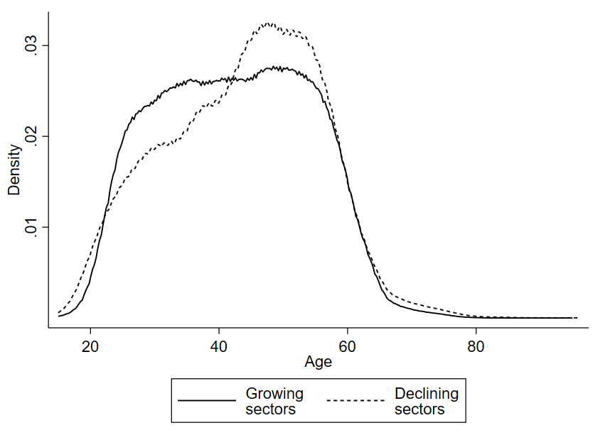
Note: EAK data 2010-2020 (pooled). Growing sectors are NACE 81, 88, 87, 86, 62, 78, 71, 69 and 68. Declining sectors are NACE 29, 25, 20, 1 and 53.

Table 11. Characteristics of workers in growing and declining sectors
 | Growing  sectors | Declining  sectors
Total | 100% | 100%
Gender
Men | 32% | 77%
Women | 68% | 23%
Education
Low | 15% | 24%
Middle | 32% | 51%
High | 53% | 25%
Age
<30 | 17% | 15%
[30-40[ | 26% | 21%
[40-50[ | 27% | 29%
>=50 | 31% | 35%
Region
Brussels | 17% | 6%
Flanders | 50% | 63%
Wallonia | 30% | 27%
Abroad | 3% | 4%
Note: EAK data 2010-2020 (pooled). Growing sectors are NACE 81, 88, 87, 86, 62, 78, 71, 69 and 68. Declining sectors are NACE 29, 25, 20, 1 and 53. The effective sample size N=26,566 in the declining sectors and N=128,213 in growing sectors.

3.4. Occupational change
Figure 4 and Table 12 show the evolution of the number of workers by occupation at the ISCO 1-digit level. Much of the employment growth over the past 35 years is concentrated in ISCO groups 2 (professionals) and 3 (technicians and professionals), which includes skilled occupations in IT, business administration, health and education. The employment share of group 2 has almost doubled from 15 percent in 1986 to over 27 percent in 2020. Employment has declined in groups 7 and 8, which include many blue-collar jobs in the manufacturing sector, and in group 4 (clerks) which includes most administrative personnel occupations.

Figure 4. Number of workers by occupation, 1986-2020
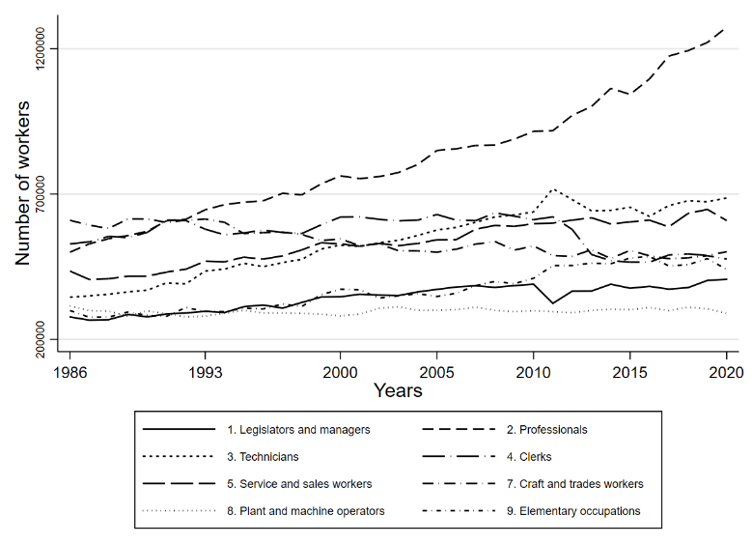

Table 12. Number of workers by occupation (ISCO 1 digit), 1986-2020
 | 1986 |  | 2020 |  | Growth
 | Workers | Percent | Workers | Percent | 1986-2020
1. Legislators, officials and managers | 277,122 | 8,4% | 406,720 | 8,7% | 46.8%
2. Professionals | 500,011 | 15,1% | 1,274,241 | 27,2% | 154.8%
3. Technicians and professionals | 344,988 | 10,4% | 686,789 | 14,7% | 99.1%
4. Clerks | 528,537 | 16,0% | 501,655 | 10,7% | -5.1%
5. Service, shops and market sales workers | 434,902 | 13,1% | 608,752 | 13,0% | 40.0%
7. Craft and related trades workers | 609,609 | 18,4% | 476,296 | 10,2% | -21.9%
8. Plant and machine workers | 314,954 | 9,5% | 288,964 | 6,2% | -8.3%
9. Elementary occupations | 299,203 | 9,0% | 440,682 | 9,4% | 47.3%
Total | 3,309,326 | 100,0% | 4,684,099 | 100,0% | 30.5%
Note: EAK data. The numbers for 1986 are harmonization estimates (see text).

Table 13 presents occupational growth at a more detailed ISCO 2-digit level. In absolute terms, the largest employment growth has been in business and administration occupations (groups 33 and 24), health professionals, legal and socio-cultural jobs, ICT jobs and teachers. In relative terms, the fastest growth has been in ICT jobs. The business administration groups 33 and 24 mainly contain workers in occupations such as executive secretaries, sales representatives, accountants, HR personnel, etcetera. Relative growth has also been very rapid in groups 26 and 34, which mainly contain social workers but also personal coaches and fitness workers.
The largest employment drop in absolute terms has been in group 72, which mainly contains blue-collar occupations such as motor vehicle mechanics, machinery mechanics, welders and other metal workers. The second largest drop has been in group 75, which mainly contains occupations such as butchers and bakers. The largest drop in relative terms has been in group 73, which mainly contains printers and press technicians.

Table 13: Number of workers by occupation (ISCO 2 digit), 1986-2020
 | 1986 | 2020 | Growth  (absolute) | Growth  (percent)
33. Business and administration associate professionals | 147,387 | 310,250 | 162,863 | 110.5%
24. Business and administration professionals | 52,616 | 214,539 | 161,923 | 307.7%
22. Health professionals | 84,741 | 237,625 | 152,884 | 180.4%
26. Legal, social and cultural professionals | 53,710 | 194,154 | 140,444 | 261.5%
25. ICT professionals | 21,889 | 138,469 | 116,580 | 532.6%
23. Teaching professionals | 225,991 | 337,700 | 111,709 | 49.4%
21. Science and engineering professionals | 61,064 | 151,754 | 90,690 | 148.5%
31. Science and engineering associate professionals | 73,978 | 162,033 | 88,055 | 119.0%
53. Personal care workers | 90,360 | 166,793 | 76,433 | 84.6%
34. Legal, social, cultural and related associate professionals | 33,209 | 91,479 | 58,270 | 175.5%
51. Personal service workers | 102,158 | 150,001 | 47,843 | 46.8%
52. Sales workers | 203,457 | 239,843 | 36,386 | 17.9%
32. Health associate professionals | 76,626 | 96,008 | 19,382 | 25.3%
35. Information and communications technicians | 13,787 | 27,313 | 13,526 | 98.1%
54. Protective services workers | 38,927 | 52,115 | 13,188 | 33.9%
71. Building and related trades workers, excluding electricians | 207,758 | 203,493 | -4,265 | -2.1%
74. Electrical and electronic trades workers | 83,206 | 68,756 | -14,450 | -17.4%
73. Handicraft and printing workers | 43,513 | 20,942 | -22,571 | -51.9%
75. Food processing, wood working, garment and other | 103,540 | 65,507 | -38,033 | -36.7%
72. Metal, machinery and related trades workers | 171,592 | 117,699 | -53,893 | -31.4%
Note: Table is sorted by absolute growth. EAK data. The numbers for 1986 are harmonization estimates (see text).

Figure 5 compares the (percent) growth rates of ISCO 1-digit occupations in Belgium with those of its neighbouring countries France, Germany and The Netherlands. Most sectors are close to the 45° diagonal implying that the process of occupational change in Belgium is broadly in line with that of neighbouring countries – although group 3 (technicians and associate professionals) has grown more rapidly and group 2 (professionals) less rapidly in Belgium. A more detailed analysis of the evolution of the employment shares of selected sectors in Belgium compared to its neighbouring countries, confirms that the evolution is similar (see Appendix D).

Figure 5. Occupational change in Belgium and neighbouring countries, 1995-2018 (EU-LFS)
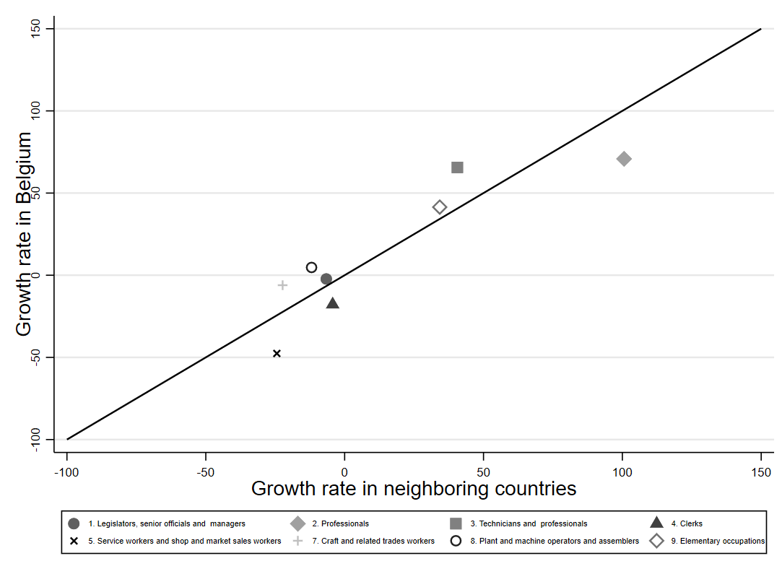

3.5 Occupational change and worker characteristics
Table 14 presents occupational employment shares in 1986 and 2020 by gender. The occupational segregation of men and women persists in 2020 with more than 28 percent of male employment in the blue-collar occupation groups 7 and 8, as opposed to less than 3 percent of female employment. However, the changing occupational structure seems to have affected both men and women in similar ways. Occupational groups 2 and 3 have increased their shares in both male and female employment by about 15 percentage points, at the expense of the other occupations. The decline of the share of the blue-collar occupation groups 7 and 8 has been stronger for men (11 percentage points) than for women (6 percentage points). The decline of the share of administrative occupations (4. Clerks) has been stronger among women. The dissimilarity index (measuring the percentage of workers who would have to change occupations in 2020 to reproduce the occupational structure in 1986) is similar for men and women.

Table 14. Occupational employment shares by gender in 1986 and 2020 (ISCO 1-digit)
Occupation | Men |  |  | Women
ISCO 1-digit group | 1986  (pct.) | 2020  (pct.) | Change (ppt.) | 1986  (pct.) | 2020  (pct.) | Change (ppt.)
1. Legislators, officials and managers | 9.6 | 10.7 | 1.2 | 6.7 | 6.4 | -0.4
2. Professionals | 13.0 | 23.6 | 10.6 | 18.9 | 31.4 | 12.4
3. Technicians and professionals | 10.3 | 14.2 | 3.9 | 10.5 | 15.2 | 4.6
4. Clerks | 13.2 | 8.2 | -4.9 | 21.0 | 13.5 | -7.5
5. Service, shops and sales workers | 8.0 | 8.0 | 0.1 | 22.2 | 18.6 | -3.6
7. Craft and related trades workers | 26.5 | 18.1 | -8.4 | 4.7 | 1.2 | -3.5
8. Plant and machine workers | 13.0 | 10.2 | -2.8 | 4.0 | 1.6 | -2.4
9. Elementary occupations | 6.6 | 6.9 | 0.3 | 11.8 | 12.2 | 0.4
Total | 100% | 100% | 0 ppt. | 100% | 100% | 0 ppt.
Dissimilarity index |  |  | 16.1 |  |  | 17.4
Note: EAK data. Change is in percentage points (ppt.). The dissimilarity index measures the difference between the distributions in 1986 and 2020.

The dissimilarity index does vary strongly according to educational level (Table 15). For workers with a degree in tertiary education, the occupational structure at the 1-digit ISCO level has hardly changed. The dissimilarity index is much higher for low-educated and even higher for middle-educated workers. This finding that middle-skill workers have experienced the greatest degree of occupational turbulence is in line with theories of routine-biased technological change and job polarization. The share of middle-skill workers (with a high school degree) in administrative occupations (4. Clerks) has halved from over 28 percent in 1986 to less than 14 percent in 2020. Middle-skill workers today are more likely to work in occupation group 9 (elementary occupations), which includes occupations such as cleaners, shelf fillers and kitchen helps, and in group 5, which includes occupations such as shop sales assistants, child care workers and cashiers. For low-skill workers, the share of blue-collar occupations in group 7 has declined substantially, while the share of elementary occupations in group 9 has increased.

Table 15. Occupational employment shares by education in 1986 and 2020 (ISCO 1-digit)
Occupation | Low |  |  | Middle |  |  | High
ISCO 1-digit group | 1986  (pct.) | 2020  (pct.) | Change (ppt.) | 1986  (pct.) | 2020  (pct.) | Change (ppt.) | 1986  (pct.) | 2020  (pct.) | Change (ppt.)
1. | 6.5 | 3.9 | -2.6 | 9.3 | 5.8 | -3.5 | 10.0 | 12.2 | 2.2
2. | 1.3 | 1.7 | 0.4 | 5.8 | 5.2 | -0.6 | 55.0 | 51.0 | -4.0
3. | 4.9 | 5.5 | 0.6 | 13.6 | 13.7 | 0.1 | 15.9 | 17.9 | 2.0
4. | 11.5 | 7.7 | -3.8 | 28.1 | 13.8 | -14.4 | 11.8 | 9.2 | -2.5
5. | 15.4 | 18.2 | 2.8 | 17.2 | 22.0 | 4.9 | 4.1 | 4.7 | 0.7
7. | 26.7 | 18.6 | -8.1 | 15.3 | 17.2 | 1.9 | 2.2 | 2.4 | 0.2
8. | 16.0 | 14.9 | -1.1 | 5.7 | 9.8 | 4.1 | 0.4 | 0.9 | 0.5
9. | 17.6 | 29.4 | 11.8 | 5.0 | 12.5 | 7.4 | 0.6 | 1.6 | 0.9
Total | 100% | 100% | 0 ppt. | 100% | 100% | 0 ppt. | 100% | 100% | 0 ppt.
Dissimilarity index |  |  | 15.6 |  |  | 18.5 |  |  | 6.5
Note: EAK data. Change is in percentage points (ppt.). The dissimilarity index measures the difference between the distributions in 1986 and 2020. ISCO groups are: 1. Legislators, officials and managers; 2. Professionals; 3. Technicians and professionals; 4. Clerks; 5. Service, shops and market sales workers; 7. Craft and related trades workers; 8. Plant and machine workers; 9. Elementary occupations.

Table 16 shows the relation between occupational change and the age of workers. The dissimilarity indices suggest that occupational changes have been greater for younger workers, which probably reflects rising educational levels. The share of younger workers has fallen drastically in the blue-collar occupations 7 and 8 and in the administrative personnel group 4, while their share has risen in the high-skill occupation group 2. Almost 20 percent of the younger workers are now in group 5, which includes occupations such as shop sales assistants, child care workers and cashiers.

Table 16. Occupational employment shares by age in 1986 and 2020 (ISCO 1-digit)
Occupation | Below 30 |  |  | [30,40[ |  |  | [40,50[ |  |  | 50 and older
ISCO 1-digit group | 1986  (pct.) | 2020  (pct.) | Change (ppt.) | 1986  (pct.) | 2020  (pct.) | Change (ppt.) | 1986  (pct.) | 2020  (pct.) | Change (ppt.) | 1986  (pct.) | 2020  (pct.) | Change (ppt.)
1. | 3.7 | 4.1 | 0.4 | 7.5 | 8.6 | 1.0 | 11.0 | 10.2 | -0.8 | 14.1 | 10.3 | -3.8
2. | 13.7 | 26.7 | 13.0 | 16.8 | 31.2 | 14.4 | 16.2 | 27.2 | 11.0 | 13.2 | 24.1 | 10.9
3. | 10.1 | 14.0 | 3.9 | 10.9 | 14.8 | 3.9 | 9.7 | 14.7 | 5.0 | 10.9 | 14.7 | 3.8
4. | 17.3 | 10.0 | -7.3 | 17.3 | 9.9 | -7.5 | 14.7 | 10.4 | -4.3 | 13.7 | 12.2 | -1.5
5. | 15.8 | 19.7 | 3.9 | 12.5 | 11.5 | -1.0 | 11.8 | 11.4 | -0.5 | 13.9 | 11.8 | -2.1
7. | 20.9 | 10.8 | -10.0 | 17.6 | 10.1 | -7.5 | 17.1 | 10.0 | -7.1 | 16.1 | 10.0 | -6.1
8. | 9.7 | 5.2 | -4.5 | 9.3 | 5.7 | -3.5 | 10.1 | 6.8 | -3.3 | 8.7 | 6.7 | -2.0
9. | 8.7 | 9.5 | 0.8 | 8.0 | 8.2 | 0.1 | 9.4 | 9.5 | 0.0 | 9.6 | 10.3 | 0.8
Total | 100% | 100% | 0 ppt. | 100% | 100% | 0 ppt. | 100% | 100% | 0 ppt. | 100% | 100% | 0 ppt.
Dissimilarity index |  |  | 21.9 |  |  | 19.5 |  |  | 16.0 |  |  | 15.5
Note: EAK data. Change is in percentage points (ppt.). The dissimilarity index measures the difference between the distributions in 1986 and 2020. ISCO groups are: 1. Legislators, officials and managers; 2. Professionals; 3. Technicians and professionals; 4. Clerks; 5. Service, shops and market sales workers; 7. Craft and related trades workers; 8. Plant and machine workers; 9. Elementary occupations.

Table 17 shows that there are substantial regional differences in occupational change. The dissimilarity indices suggest that occupational turbulence is more pronounced in cities. The share of administrative jobs (group 4) in the (urban) region of Brussels has collapsed from 27 percent in 1986 to less than 12 percent in 2020. It is worth repeating that these disappearing administrative jobs used to be important for middle-skill workers: back in 1986, almost 30 percent of middle-skill workers were in this group (see Table 15). The share of high-skill professional jobs (group 2) in Brussels has increased by more than 19 percentage points. The fact that the rising occupations in Brussels are in the high-skill group 2, makes the changing occupational structure particularly challenging for middle-skill workers.

Table 17. Occupational employment shares by region in 1986 and 2020 (ISCO 1-digit)
Occupation | Brussels |  |  | Flanders |  |  | Wallonia
ISCO 1-digit group | 1986  (pct.) | 2020  (pct.) | Change (ppt.) | 1986  (pct.) | 2020  (pct.) | Change (ppt.) | 1986  (pct.) | 2020  (pct.) | Change (ppt.)
1. | 10.5 | 12.3 | 1.8 | 8.0 | 8.1 | 0.1 | 8.2 | 7.6 | -0.6
2. | 18.5 | 37.9 | 19.3 | 13.4 | 24.0 | 10.6 | 17.0 | 27.6 | 10.5
3. | 13.6 | 14.3 | 0.7 | 10.1 | 15.2 | 5.1 | 9.3 | 13.2 | 3.9
4. | 26.9 | 11.8 | -15.1 | 14.6 | 10.8 | -3.8 | 13.4 | 10.2 | -3.2
5. | 9.9 | 10.4 | 0.5 | 12.5 | 13.3 | 0.7 | 16.3 | 14.5 | -1.8
7. | 10.6 | 4.5 | -6.1 | 20.4 | 11.2 | -9.1 | 18.8 | 11.1 | -7.6
8. | 3.9 | 2.1 | -1.9 | 12.0 | 7.6 | -4.4 | 8.3 | 5.6 | -2.7
9. | 6.0 | 6.9 | 0.9 | 8.9 | 9.8 | 0.9 | 8.7 | 10.2 | 1.5
Total | 100% | 100% | 0 ppt. | 100% | 100% | 0 ppt. | 100% | 100% | 0 ppt.
Dissimilarity index |  |  | 23.2 |  |  | 17.4 |  |  | 15.9
Note: EAK data. Change is in percentage points (ppt.). The dissimilarity index measures the difference between the distributions in 1986 and 2020. ISCO groups are: 1. Legislators, officials and managers; 2. Professionals; 3. Technicians and professionals; 4. Clerks; 5. Service, shops and market sales workers; 7. Craft and related trades workers; 8. Plant and machine workers; 9. Elementary occupations.

Table 18 describes the characteristics of workers in growing versus declining ISCO 2-digit occupations. The growing occupations are the 10 occupations with the largest absolute employment growth such as business administration, health professionals, social workers and ICT workers (see Table 13). The declining occupations include the 4 blue-collar occupations with the largest negative employment growth. Table 18 reveals that there are strong relations with gender, skill and region of employment. 94 percent of the workers in the declining occupations are men, whereas the majority of workers in the growing occupations are women. 90 percent of the workers in declining occupations are low- or middle-skilled, whereas almost three quarters of the workers in the growing occupations are high-skilled. The employment share of the (urban) Brussels region is much larger in the growing occupations than in the declining occupations.

Table 18. Characteristics of workers in growing and declining occupations
 | Growing  occupations | Declining  occupations
Total | 100% | 100%
Gender
Men | 45% | 94%
Women | 55% | 6%
Education
Low | 4% | 28%
Middle | 22% | 62%
High | 73% | 10%
Age
<30 | 15% | 20%
[30-40[ | 27% | 24%
[40-50[ | 27% | 26%
>=50 | 31% | 30%
Region
Brussels | 21% | 9%
Flanders | 46% | 55%
Wallonia | 29% | 29%
Abroad | 4% | 4%
Note: EAK data 2013-2020 (pooled). Growing occupations are ISCO 33, 242, 22, 26, 25, 23, 21, 31, 53 and 34. Declining occupations are ISCO 72, 75, 73 and 74 (see Table 13). The effective sample size N=42,388 in the declining occupations and N=163,026 in growing occupations.

3.6 Job polarization
To study the extent to which the Belgian labour market has experienced job polarization, we categorize occupations into broad skill levels as has frequently been done in the literature on job polarization. For Figure 6 we follow ILO (2012) and Zilian et al. (2021) to collapse occupations into four skill levels (see the correspondence table in appendix E) and then study the evolution of the share of workers in each of these categories of occupations. Figure 6 shows that the share of workers in middle-low-skill occupations has fallen substantially by about 20 percentage points, while the shares of the other types of occupations have increased – particularly the share of high-skill occupations which has increased by about 15 percentage points.
For Figure 7, we follow Autor (2014) and collapse occupations into manual, routine and abstract occupations (see the correspondence table in appendix E). The share of workers in routine occupations has fallen by over 10 percentage points over the past 35 years in Belgium, and this share has gone to abstract occupations (the share of manual occupations has been roughly constant over time).

Figure 6. Job polarization – the decline of middle-low skill occupations in Belgium, 1986-2020
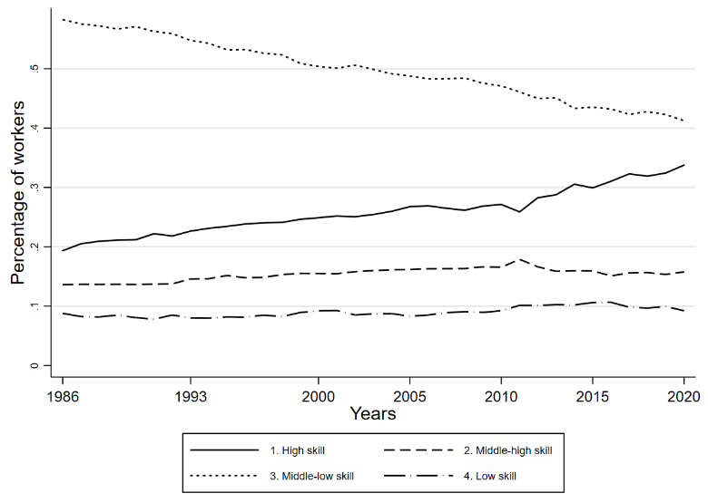

Figure 7. Job polarization – the decline of routine occupations in Belgium, 1986-2020
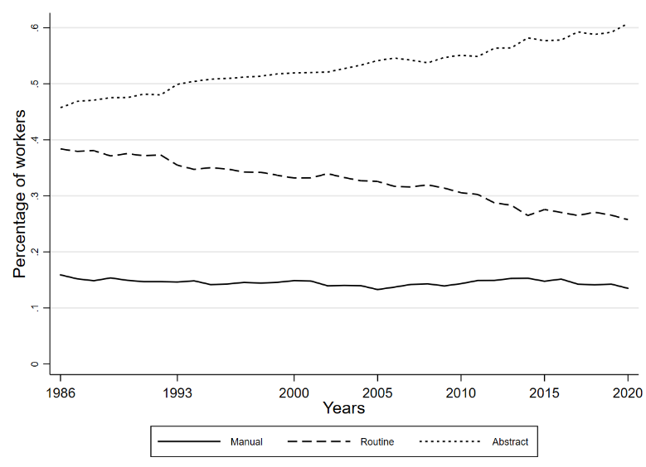

3.7 Worker flows between occupations
To study worker flows between occupations, we use EU-SILC data for the period 2012-2020 in which the same respondents are repeatedly surveyed at different moments in time (longitudinal data). Table 19 contains a transition matrix at the 1-digit ISCO level to show the percentage of workers who move to another occupation over a 1-year period, the percentage who move to non-employment and the percentage of workers who remain in the same occupation (the percentages add up to 100 percent in each row). The highest transition rate to other occupations is in ISCO category 8 (“Plant and machine workers”) while the lowest are in categories 0 (“Armed forces”) and 2 (“Professionals”). Table 20 presents the same transition matrix but for more detailed occupational categories at the 2-digit ISCO level. Interestingly, the lowest transition rate is among ICT professionals, where only about 1 percent move to another occupation each year. In others words, workers who end up in an ICT occupation are very likely to stay in that occupation. The highest transition rate is among plant and machine operators, where more than 6 percent move to another occupation each year.

Table 19. Yearly transitions between occupations (ISCO08 1 digit), 2012-2020
 |  | Occupation in year t
Occupation in year t-1 | N | Same  occupation | Other  occupations | Non-employment
0. Armed forces | 176 | 93.75% | 1.14% | 5.11%
1. Officials and managers | 2,047 | 93.06% | 2.88% | 4.05%
2. Professionals | 8,375 | 94.36% | 1.65% | 3.99%
3. Technicians and associate prof. | 4,692 | 91.75% | 3.30% | 4.94%
4. Clerks | 4,291 | 91.07% | 2.66% | 6.27%
5. Service and sales workers | 3,671 | 87.44% | 2.72% | 9.83%
6. Skilled agricultural and fishery | 421 | 89.07% | 1.90% | 9.03%
7. Craft and related trades workers | 2,686 | 90.36% | 2.27% | 7.37%
8. Plant and machine workers | 1,665 | 88.59% | 3.96% | 7.45%
9. Elementary occupations | 2,618 | 85.98% | 2.56% | 11.46%
Note: EU-SILC data 2012-2020. N=30,642.

Table 20. Yearly transitions between occupations (ISCO08 2 digit), 2012-2018
ISCO | Label | N | Same | Other | Out
25 | ICT professionals | 398 | 96.23% | 1.01% | 2.76%
23 | Teaching professionals | 1,570 | 94.27% | 1.21% | 4.52%
54 | Protective services workers | 248 | 94.35% | 1.21% | 4.44%
94 | Food preparation assistants | 144 | 82.64% | 1.39% | 15.97%
22 | Health professionals | 711 | 94.51% | 1.69% | 3.80%
71 | Building and related trades workers | 667 | 90.25% | 1.80% | 7.95%
83 | Drivers and mobile plant operators | 554 | 90.97% | 1.81% | 7.22%
26 | Legal, social and cultural professionals | 700 | 93.57% | 1.86% | 4.57%
11 | Chief executives, senior officials and legislators | 200 | 92.50% | 2.00% | 5.50%
53 | Personal care workers | 659 | 88.32% | 2.12% | 9.56%
21 | Science and engineering professionals | 594 | 94.44% | 2.19% | 3.37%
91 | Cleaners and helpers | 998 | 86.17% | 2.20% | 11.62%
72 | Metal, machinery and related trades workers | 405 | 91.11% | 2.47% | 6.42%
14 | Hospitality, retail and other services managers | 182 | 92.31% | 2.75% | 4.95%
32 | Health associate professionals | 491 | 92.67% | 2.85% | 4.48%
31 | Science and engineering associate professionals | 518 | 93.63% | 2.90% | 3.47%
41 | General and keyboard clerks | 1,290 | 91.47% | 2.95% | 5.58%
12 | Administrative and commercial managers | 432 | 93.75% | 3.01% | 3.24%
42 | Customer services clerks | 215 | 86.05% | 3.72% | 10.23%
51 | Personal service workers | 483 | 84.89% | 3.73% | 11.39%
33 | Business and administration associate professionals | 1,138 | 90.60% | 3.78% | 5.62%
13 | Production and specialized services managers | 444 | 92.34% | 3.83% | 3.83%
43 | Numerical and material recording clerks | 794 | 90.43% | 3.90% | 5.67%
44 | Other clerical support workers | 202 | 88.61% | 3.96% | 7.43%
52 | Sales workers | 719 | 84.14% | 4.17% | 11.68%
74 | Electrical and electronic trades workers | 206 | 85.92% | 4.37% | 9.71%
34 | Legal, social, cultural and related associate professionals | 315 | 90.48% | 4.44% | 5.08%
75 | Food processing, wood working, garment and other | 175 | 85.71% | 4.57% | 9.71%
96 | Refuse workers and other elementary workers | 152 | 81.58% | 4.61% | 13.82%
93 | Labourers in construction, manufacturing and transport | 228 | 85.09% | 5.26% | 9.65%
24 | Business and administration professionals | 640 | 90.63% | 5.63% | 3.75%
81 | Stationary plant and machine operators | 298 | 86.24% | 6.38% | 7.38%
Note: Table is sorted by the percentage moving to other occupations.

Table 21 presents the results of a regression analysis which studies how worker characteristics are related to these transition rates and how these transition rates differ across occupations after controlling for demographic characteristics. The table presents three linear regression models in which the dependent variables are binary variables that take the value 1 if a worker stays in the same occupation between year t-1 and year t, and 0 if not (model 1), whether a worker moves to another occupation (model 2), and whether a worker moves to non-employment (model 3). The estimated coefficients for age imply that, controlling for all the other variables that are included into the model, the probability to move to another occupation is 8 percentage points (ppt) lower for workers aged 56 or more compared to workers younger than 25. So, the probability to move to another occupation declines sharply with age. Older workers are also more likely to move to non-employment (retirement, unemployment, disability,…). There are no significant gender differences. Higher educated workers and more experienced workers are more likely to stay in their occupation and they are less likely to move to non-employment. Plant and machine workers are the most likely to move to another occupation, whereas workers in ISCO category 9 (“Elementary occupations”) are the most likely to move to non-employment.
Table 21. Linear Probability Models of transitions between occupations (ISCO08 1 digit), 2012-2020
 | (1)  Stay in the occupation | (2)  Move to  other occupation | (3)  Move to  non-employment
Constant | 0.80** | 0.09** | 0.11**
Female | 0.00 | -0.00 | 0.00
Age (ref=[16-25])
[26-35] | 0.06** | -0.04** | -0.02
[36-45] | 0.06** | -0.06** | 0.00
[46-55] | 0.05** | -0.07** | 0.02*
[56-65] | -0.01 | -0.08** | 0.08**
Education (ref=Primary)
Secondary | 0.04** | -0.00 | -0.04**
Post-secondary non-tertiary | 0.07** | 0.01 | -0.07**
Tertiary | 0.06** | 0.00 | -0.06**
Experience (ref=[0-10])
[11-20] | 0.04** | -0.00 | -0.04**
[21-30] | 0.07** | -0.01 | -0.07**
[31-40] | 0.07** | -0.01* | -0.06**
Occupation (ref=2. Professionals)
0. Armed forces | -0.02 | -0.01 | 0.02
1. Officials and managers | -0.01* | 0.02** | -0.00
3. Technicians and associate prof. | -0.02** | 0.02** | 0.00
4. Clerks | -0.03** | 0.02** | 0.01**
5. Service and sales workers | -0.05** | 0.01** | 0.03**
6. Skilled agricultural and fishery | 0.02 | 0.00 | -0.02*
7. Craft and related trades workers | -0.02** | 0.01 | 0.02**
8. Plant and machine workers | -0.05** | 0.03** | 0.02*
9. Elementary occupations | -0.06** | 0.01* | 0.04**
R² | 0.02 | 0.01 | 0.03
N | 28,889 | 28,889 | 28,889
NOTE: **p<0.01 and *p<0.05. The dependent variables are binary variables indicating whether a worker stayed in the same occupation, moved to another occupation, and moved to non-employment – between year t-1 and year t.

4. Discussion and conclusions
The main findings of this study can be summarized as follows. Over the past 35 years, the total number of jobs in the Belgian labour market has grown by more than a third. This impressive job growth is hard to reconcile with the mistaken view that technological change leads to substantial job losses and unemployment. Some sectors and occupations have indeed declined, but many others have grown. From a sectoral perspective (in terms of what products are being produced), the largest employment growth has been witnessed in cleaning and security services, hospital and care work, computer programming and employment agencies. The largest drops in employment have been concentrated in a number of manufacturing sectors, as well as in the agricultural sector. From an occupational perspective (in terms of which tasks workers do), the largest employment growth was seen in business and administration occupations (executive secretaries, sales representatives, accountants, HR personnel,…), health professionals, legal and socio-cultural jobs, ICT jobs and teachers. In relative terms, the fastest growth can be noticed for ICT jobs and social workers but also for personal coaches and fitness workers. The largest employment drops have been in blue-collar occupations such as motor vehicle mechanics, machinery mechanics, printers and press technicians, etc. This industrial and occupational restructuring is broadly in line with the evolution in Belgium’s neighbouring countries France, Germany and The Netherlands.
These evolutions have had very different impacts for different parts of the labour force. Over the past 35 years, the share of women in the employed population, the share of high-skilled workers and the share of older workers have increased substantially. The rising female employment has been mainly absorbed by the expanding sectors of education, health and social work, and business activities (real estate, legal and accounting, cleaning and security, …), while there have been declines in the shares of some sectors in female employment such as retailing and manufacturing. Male employment has declined dramatically in the manufacturing sector, and it has grown in business activities. In terms of occupations, the well-known horizontal gender segregation persists, but the broad occupational changes have affected men and women in similar ways. An exception is the decline in administrative occupations (clerks), which has been stronger among women while the decline in blue-collar occupations has been stronger among men. The substantial declines of manual routine jobs in manufacturing (a male dominated occupation) and secretary office jobs (a female dominated occupation) show that no gender is immune to the challenges posed by the digital revolution.
Sectoral and occupational change is also strongly related to skills. 35 years ago, low-skilled workers used to be concentrated in the manufacturing sector while greater shares today work in sectors such as cleaning, security services, health and social work. The occupational structure has hardly changed for high-skilled workers. Our analyses thus show that occupational changes have been more present for low-skilled workers, in the sense that much larger shares of low- and middle-skilled workers have been reallocated to other sectors and occupations than is the case for high-skilled workers. We find that the occupational turbulence has been most severe for middle-skilled workers which is in line with theories of routine-biased technological change and job polarization.
Older workers have seen declining employment shares in sectors such as agriculture and retail. In terms of occupations, younger workers have seen substantial drops in the employment shares in blue-collar occupations and in administrative occupations, whereas almost 20 percent of the younger workers today work as shop sale assistants, child care workers and cashiers.
The evolutions have also been uneven across geographical space, especially in terms of occupational change. The share of administrative jobs in the urban region of Brussels has collapsed from 27 percent in 1986 to less than 12 percent in 2020, while the shares of high-skilled occupations is increasing in this region. Our analysis suggest that occupational change has been more pronounced in the urban Brussels region than in other Belgian regions, and that this changing occupational structure has been particularly challenging for middle-skill workers.
The fact that occupational change has been very uneven across worker characteristics becomes even more clear if we compare workers in growing and declining occupations (in the analyses we identified growing and declining occupations as occupations that experienced the largest absolute change in the number of workers employed). 94 percent of the workers in the declining occupations are men, compared to only 45 percent in the growing occupations. Only 10 percent of the workers in declining occupations are high-skilled, compared to 73 percent in the growing occupations. Finally, 21 percent of the workers in growing occupations are employed in the urban region of Brussels, compared to only 9 percent in the declining occupations.
Our evidence also shows that the Belgian labour market has been experiencing job polarization. Over the past 35 years, the share of workers in middle-low-skill occupations has fallen substantially by about 20 percentage points and the share of workers in what can be identified as routine occupations has fallen by about 10 percentage points. The growth has been in so-called abstract occupations while the share of manual occupations has been roughly constant.
Part of the occupational restructuring results from workers moving from one occupation to another, while another part arises from the fact that young workers enter the labour market in other (growing) occupations. Our analysis of occupational mobility that looked at yearly occupational changes in longitudinal data, shows that workers in declining occupations do show much higher levels of mobility than workers in growing occupations such as ICT professionals, teachers, and security workers, which are essentially absorbing states in the sense that once workers start in these occupations, they are very unlikely to move to other occupations. This implies that the changing occupational structure is at least partly channelled through occupational mobility of workers. We also find that occupational mobility sharply decreases with age, which could be explained by the fact that workers and/or employers are less likely to invest in the required human capital for such changes as workers get older.
This study has a number of limitations. The main limitation is that this study cannot distinguish the effects of technological change on the labour market from other determinants such as international trade. In the case of some occupational changes which we observed, such as the decline in administrative personnel or printers and press technicians, it is plausible to assume the changes are driven by technological change. However, in the case of the decline in manufacturing jobs, globalization and increased import competition from countries such as China have undoubtedly played a role as well. Another limitation is related to the fact that it is hard to measure occupations consistently over longer-term time periods. To deal with changes of occupational classifications over time and create consistent time-series, we adopted a statistical harmonization method which relies on additional assumptions that are explained in the section on methodology above. Moreover, an occupation is a set of jobs with similar tasks, so measuring occupations in practice always involves some arbitrary decision on the level of required aggregation and detail (an extreme view would be that no two workers do exactly the same tasks so that each occupation contains only one worker). Some aggregation is needed to identify and describe patterns in clear and meaningful ways, but aggregation comes at the cost of reduced image resolution and accuracy. Another limitation is that the relations we describe with worker characteristics (both in the bivariate tables and the regression analyses) are subject to potential omitted variable bias, so the findings in this report should be interpreted as correlations rather than causal effects. A final limitation is that by focusing on the effects at the level of occupations, we ignore how technological change may have been affecting the task composition within occupations. This latter issue of how work tasks have been evolving and what are the implications for the skill requirements of workers is the focus of the next chapter.

References
Autor, D. (2014). Polanyi's paradox and the shape of employment growth. National Bureau of Economic Research Working Paper 20485.
Eurostat (2008). NACE Rev. 2: Statistical classification of economic activities in the European Community. Eurostat, European Commission retrieved from https://ec.europa.eu/eurostat/documents/3859598/5902521/KS-RA-07-015-EN.PDF
ILO, 2012. International Labour Organization: International standard classification of occupations (ISCO-08).
Muçaj, E. (2017). Employment by occupations in the Belgian LFS: Difficulties resulting from the introduction of the ISCO08 classification. Master’s Thesis, University of Antwerp.
Zilian, L. S., Zilian, S. S., & Jäger, G. (2021). Labour market polarisation revisited: evidence from Austrian vacancy data. Journal for Labour Market Research, 55(1), 1-17.

